
Marchwood Junior School – Science Curriculum

Science is curiosity in thoughtful action about the world and how it behaves.

Intent:
Develop knowledge and understanding of…
- How the human body works.
- Plants and animals including the seven life processes
- The properties of materials and states of matter.
- Light and sound and how they travel
- Forces, including push and pull, and how they interact with objects and their affect on the world around us.
- The solar system and the position of the earth in space.
- How to carry out an investigation and understand why

Develop the ability to…
- observe patterns
- ask questions
- make predictions based on scientific knowledge
- understand variables can affect an investigation
- Plan and choose variables to test, control and measure for a fair test
- identify, group and classify using scientific knowledge to help understand the world around them
- Measure accurately to collect reliable data
- Present data
- Answer questions using data.
- Consider reliability of scientific work
- Apply knowledge in real world contexts

Communicate
- With the use of scientific language.
- Findings
- Considered conclusions and further predictions.

Implementation:
How do we help children develop knowledge into schema in their long-term memory?

Whole – Part – Whole | Regular recall of knowledge | Combine visual with text | Grouping knowledge | Spaced Learning
Challenge resides in the curriculum and not in the individual lesson. | The act of retrieval strengthens memory, making information more retrievable. | Images can be more easily remembered than words and provide a memory cue. | Understanding is the connections that form between knowledge. | Spacing recall helps create defined pathways in memory.  Knowledge moves from episodic to semantic.
Composite questions are broken down into their specific components of knowledge and developed over time. | Frequent low stakes testing of scientific facts and simple investigatory skills. | Knowledge organisers and work booklets. | Class mind maps organise knowledge.  New knowledge is connected to pre-existing knowledge. | Low stakes testing revisits prior knowledge. Components of knowledge are added to and developed over time.

Avoid overload | Feedback Loops | Articulate knowledge and understanding | Enrichment | Application of Knowledge in a context
Working memory has a limited capacity. Learners cannot be overwhelmed with too much. | Assessment as feedback ensures teaching matches understanding | Articulating understanding demonstrates individual schema including being able to make reasonable predictions and understand results | Going beyond the classroom to provide purpose and meaning. | Science is the study of the world around us and learning should be rooted here
Knowledge is broken down into clearly defined parts and revisited regularly. | - AFL  - Direct Teaching develops novice schemas of knowledge  - Intervene  - Systematic monitoring | End of unit assignments explore children’s connections in knowledge. Regular investigational studies allow time for articulating predictions and for drawing conclusions | Visits from local science museums.  STEAM day- secondary school. | Investigations to discover how taught knowledge links to the world around us.
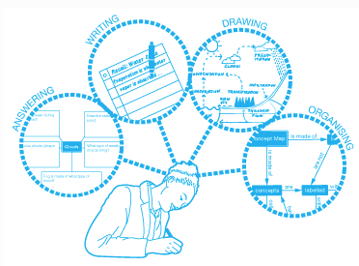
(December 2019)

