
Marchwood Junior School – Religious Education Curriculum

Religious Education is ….

Intent:
Develop knowledge of…
- Key concepts and their role in different religions and beliefs.
- Religions of Christianity, Judaism and Sikhism
- Examples of their traditions and beliefs and their background stories / events
- Vocabulary, to include: Religious terms, objects and buildings for Christianity, Judaism and Sikhism. (See vocabulary must know document for progression across curriculum).
- How religious beliefs might affect our own lives and living with believers of those religions

Develop an understanding of key religions and the application of this understanding to their own and other’s lives using the circle of learning consisting of:
- Enquire (concepts and their significance in religious and non-religious experiences)
- Contextualise (the concept within religious practise and explore diversity of practise and belief)
- Evaluate (the concept within one or more religions)
- Communicate (their own understanding and respond to the concept)
- Apply (their own understanding of the concept to situations in their own and other’s lives)

Communicate their own understanding and responses to concepts

Implementation:
How do we help children develop knowledge into schema in their long-term memory?

Whole – Part – Whole | Regular recall of knowledge | Grouping knowledge | Spaced Learning | Avoid overload
Challenge resides in the curriculum and not in the individual lesson | The act of retrieval strengthens memory, making information more retrievable. | Understanding is the connections that form between knowledge | Spacing recall helps create defined pathways in memory  Knowledge moves from episodic to semantic | Working memory has a limited capacity. Learners cannot be overwhelmed with too much.
Complex concepts and religions are broken down into their specific components / beliefs / traditions. | Frequent low stakes testing of core knowledge and vocabulary. These are based on key religious concepts, narratives and ideas. | Class mind maps organise knowledge  New knowledge is connected to pre-existing knowledge. Revisit knowledge taught in previous year groups and units. | Low stakes testing revisits prior knowledge.  Knowledge of religions build over time with new concepts / traditions / beliefs added. Comparisons between religions and across religions develop. | Knowledge is broken down into clearly defined parts. Repeated LSR questions to build up retention of core knowledge. Pictures and diagrams used appropriately.

Feedback Loops | Articulate knowledge and understanding | Enrichment
Assessment as feedback ensures teaching matches understanding | Articulating understanding demonstrates individual schema | Going beyond the classroom to provide purpose and meaning.
AFL at beginning of unit.  Direct Teaching develops novice schemas of knowledge  Low stakes testing base of recalling of knowledge and intervention if needed. | End of unit assignments explore children’s connections in knowledge. Outcomes encourage children to reflect on own thoughts and ideas around key concept and belief explored. | Visits to local church (Christianity).  Visits from local vicar (Christianity).  Visits from SCM for question of faith days.  (Christianity).  Visit to Southampton Gurdwara. (Sikhsim).

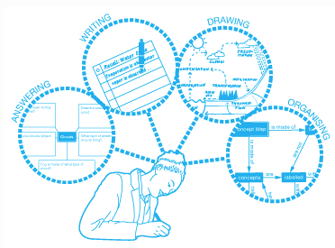
(January 2022)

