
Marchwood Junior School – PSHE Curriculum

Intent:
Develop knowledge of…
- Our physical and mental health and wellbeing
- Relationships – positive and negative
- Living in the wider world – communities, rules, rights and consequences

Develop an understanding of…
- Our rights and responsibilities as human beings
- Consequences of out actions eg in regard to antisocial behaviour, drug abuse, poor diet, bullying, prejudice etc
- How to be safe and recognise risks eg on-line, in school, at home and in the wider community
- How to build and maintain positive relationships and how to resolve conflicts
- When are where to ask for help and guidance
- Transitions in our lives eg puberty, changing schools, loss, family circumstances

Communicate
- With the use of appropriate language identified in lessons eg diverse, prejudice, human rights
- Respectfully and with consideration of the views of others
- Constructively, challenging ideas
- With reflection and insight

Implementation:
How do we help children develop knowledge into schema in their long-term memory?

Whole – Part – Whole | Regular recall of knowledge | Combine visual with text | Grouping knowledge | Spaced Learning
Challenge resides in the curriculum and not in the individual lesson. | The act of retrieval strengthens memory, making information more retrievable. | Images can be more easily remembered than words and provide a memory cue. | Understanding is the connections that form between knowledge. | Spacing recall helps create defined pathways in memory.  Knowledge moves from episodic to semantic.
Composite questions are broken down into their specific components of knowledge and developed over time. | Frequent low stakes testing of vocabulary and key knowledge. | Knowledge organisers, double page spreads and mind maps. | Class mind maps organise knowledge.  New knowledge is connected to pre-existing knowledge. | Low stakes testing revisits prior knowledge. Components of knowledge are added to and developed over time.

Avoid overload | Feedback Loops | Articulate knowledge and understanding | Enrichment | Application of Knowledge in a context
Working memory has a limited capacity. Learners cannot be overwhelmed with too much. | Assessment as feedback ensures teaching matches understanding | Articulating understanding demonstrates individual schema including and develops personal views | Going beyond the classroom to provide purpose and meaning. | PSHE relates to people and how we live in the world. Work links to real life scenarios.
Knowledge is broken down into clearly defined parts and revisited regularly. | AFL, direct teaching develops novice schemas of knowledge, interventions, monitoring. | End of unit assignments/ outcomes explore children’s connections in knowledge and demonstrate their understanding. | Visits from:  PCSO  Charity (guide dogs)  Local Council  Whole school weeks:  Anti-bullying  Walk to school  Mental Health  Parental support:  Yr 4 girls’ evening  Whole school unit:  Democracy – vote for Head Boy and Girl | Outcomes offer opportunities to reflect on how we deal with real life situations.
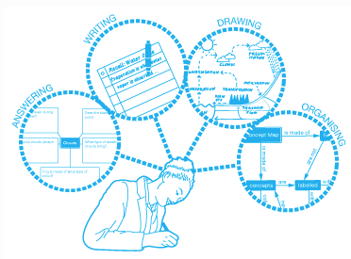
(January 2020)

