
Marchwood Junior School – Music Curriculum
# inspiring children through appreciation, composition and performance

Intent:
- Develop a knowledge of how to sing and play musically and become confident in this.
- play and perform in solo and ensemble contexts
- use voices and playing musical instruments with increasing accuracy, fluency, control and expression

- Develop an understanding of musical composition
- improvise and compose music for a range of purposes using the inter-related dimensions of music
- listen with attention to detail and recall sounds with increasing aural memory.

- Develop a knowledge of how to organise and manipulate ideas within musical structures and reproduce sounds from aural memory
- use and understand stave and other musical notations

- Appreciate and understand a wide range of high-quality live and recorded music drawn from different traditions, eras and cultures as well as from great composers and musicians

Implementation:
How do we help children develop knowledge into schema in their long-term memory?

Whole – Part – Whole | Regular recall of knowledge | Combine visual with text | Grouping knowledge | Spaced Learning
Challenge resides in the curriculum and not in the individual lesson | The act of retrieval strengthens memory, making information more retrievable. | Images can be more easily remembered than words and provide a memory cue | Understanding is the connections that form between knowledge | Spacing recall helps create defined pathways in memory  Knowledge moves from episodic to semantic
Composite questions are broken down into their specific components of knowledge | Frequent low stakes testing of significant historical facts and narratives  Use of ‘carnet’ | Knowledge organisers | Class mind maps organise knowledge  New knowledge is connected to pre-existing knowledge | Low stakes testing revisits prior knowledge

Avoid overload | Feedback Loops | 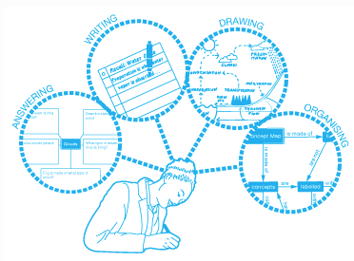  Articulate knowledge and understanding
Working memory has a limited capacity. Learners cannot be overwhelmed with too much. | Assessment as feedback ensures teaching matches understanding | Articulating understanding demonstrates individual schema
Knowledge is broken down into clearly defined parts. | Direct Teaching develops novice schemas of knowledge | End of unit assignments explore children’s connections in knowledge
(January 2022)

