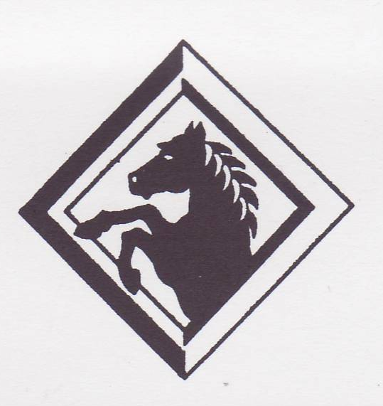
Marchwood Junior School – History Curriculum

Intent:
Develop knowledge of…
- Local, British and Wider World History
- Clear narratives within and across periods of time
- Historical terms

Develop an understanding of key historical concepts
- Chronology – Develop a historical context
- Diversity – Consider the similarities and differences of different peoples experiences
- Change – Contemplate how society has progressed, transformed, demised and evolved over periods of time.
- Causes and consequences – Study reasons for, and the results of, events in time.
- Significance – Reflect on the impact on human society.
- Interpretation – Analyse sources and evidence.

Communicate findings and interpretations to address historical questions

Implementation:
How do we help children develop knowledge into schema in their long-term memory?

Whole – Part – Whole | Regular recall of knowledge | Combine visual with text | Grouping knowledge | Spaced Learning
Challenge resides in the curriculum and not in the individual lesson | The act of retrieval strengthens memory, making information more retrievable. | Images can be more easily remembered than words and provide a memory cue | Understanding is the connections that form between knowledge | Spacing recall helps create defined pathways in memory  Knowledge moves from episodic to semantic
Composite questions are broken down into their specific components of knowledge | Frequent low stakes testing of significant historical facts and narratives | Knowledge organisers | Class mind maps organise knowledge  New knowledge is connected to pre-existing knowledge | Low stakes testing revisits prior knowledge

Avoid overload | Feedback Loops | 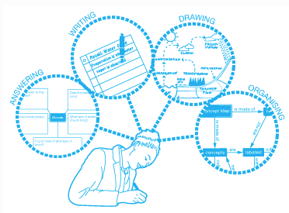  Articulate knowledge and understanding
Working memory has a limited capacity. Learners cannot be overwhelmed with too much. | Assessment as feedback ensures teaching matches understanding | Articulating understanding demonstrates individual schema
Knowledge is broken down into clearly defined parts. | Direct Teaching develops novice schemas of knowledge | End of unit assignments explore children’s connections in knowledge
(June 2019)

