
Marchwood Junior School – Geography Curriculum
Be inquisitive about your world.

Geography is the study of the complexity of the world around us: considering the earth as the home of people and understanding the diversity of countries and cultures.

Intent:

Develop knowledge of…
- The local area including settlements in the New Forest, Southampton and Winchester as well as cities of the United Kingdom
- The continents, countries and oceans of the world focusing on European countries, and North and South America.
- OS symbols and map features such as scale
- Key geographical vocabulary of human and physical geography
- The different land uses such as cultivation, pasture, housing etc
- The formation of physical geographical land features: rivers, coasts and volcanoes.
- Longitude, latitude, Equator, Hemispheres, Arctic and Antarctic Circle, Tropics of Cancer and Capricorn and time zones.
- What different places are like and why they are like that from their location and how and why places will be similar and different.

Learn how to…
- Read world maps, atlases and globes accurately;
- Read and follow local maps accurately using symbols and keys to locate features
- Use the eight points of a compass, and read 4 and 6 figure grid references, for positional reference.
- Carry out field work to observe and study the geography of local areas using accurate sketch maps, plans and technology.
- Research and analyse geographical data.
- Compare and contrast human and physical geography in different areas.
- Form and articulate opinions on potentially negative effects of land use on the environment.
- Consider and evaluate different options for land use in the future, considering different stakeholders’ opinions.

Implementation:
How do we help children develop knowledge into schema in their long-term memory?

Whole – Part – Whole | Regular recall of knowledge and practice of skills | Combine visual and practical with text | Grouping knowledge | Spaced Learning
Challenge resides in the curriculum and not in the individual lesson | The act of retrieval strengthens memory, making information more retrievable. | Images and practical field studies can be more easily remembered than words and provide a memory cue | Understanding is the connections that form between knowledge | Spacing recall helps create defined pathways in memory  Knowledge moves from episodic to semantic
Key geographical vocabulary is broken down and taught in the context of local studies | Frequent low stakes testing of vocabulary, location of countries and map reading skills | Knowledge organisers and workbooks | Class mind maps organise knowledge  New knowledge is connected to pre-existing knowledge  Geography is taught within other subjects such as English and linking to settings of stories in different countries/continents | Low stakes testing revisits prior knowledge

Avoid overload | Feedback Loops | 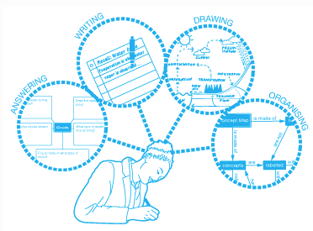  Articulate knowledge and understanding
Working memory has a limited capacity. Learners cannot be overwhelmed with too much. | Assessment as feedback ensures teaching matches understanding | Articulating understanding demonstrates individual schema
Knowledge is broken down into clearly defined parts. | AfL  Fluid grouping  Direct Teaching develops novice schemas of knowledge  Systematic monitoring | End of unit assignments explore children’s connections in knowledge
(November 2021)

