
Marchwood Junior School – French Curriculum

Intent:
Develop a knowledge of how to communicate ideas facts and feelings in French through:

- Speaking and listening:
- Listen attentively to spoken language
- Ask and answer questions
- Speak in sentences, using familiar vocabulary, phrases and basic language structures
- Develop accurate pronunciation and intonation

- Reading and writing:
- Read carefully and show understanding of words, phrases and simple writing
- Write phrases from memory and adapt these to create new sentences.

3) Basic French grammar:
- Feminine and masculine forms
- Conjugation of high-frequency verbs

Implementation:
How do we help children develop knowledge into schema in their long-term memory?

Whole – Part – Whole | Regular recall of knowledge | Combine visual with text | Grouping knowledge | Spaced Learning
Challenge resides in the curriculum and not in the individual lesson | The act of retrieval strengthens memory, making information more retrievable. | Images can be more easily remembered than words and provide a memory cue | Understanding is the connections that form between knowledge | Spacing recall helps create defined pathways in memory  Knowledge moves from episodic to semantic
Composite questions are broken down into their specific components of knowledge | Frequent low stakes testing of significant historical facts and narratives  Use of ‘carnet’ | Knowledge organisers | Class mind maps organise knowledge  New knowledge is connected to pre-existing knowledge | Low stakes testing revisits prior knowledge

Avoid overload | Feedback Loops | 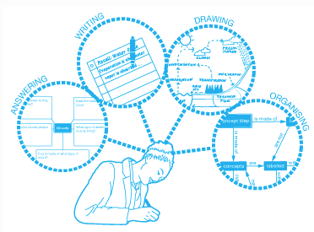  Articulate knowledge and understanding
Working memory has a limited capacity. Learners cannot be overwhelmed with too much. | Assessment as feedback ensures teaching matches understanding | Articulating understanding demonstrates individual schema
Knowledge is broken down into clearly defined parts. | Direct Teaching develops novice schemas of knowledge | End of unit assignments explore children’s connections in knowledge
(June 2019)

