
Marchwood Junior School – DT Curriculum

Purposeful Product Innovators

Intent:
Develop knowledge of…
- Various techniques in a range of media including electrical, tool use, sewing and cooking (procedure knowledge)
- Design terminology and skills to be used with increasing independence
- Purposeful design ideas and how a variety of materials will help to create them
- The importance of great design in the past, now and for the future
- The work of key and influential designers

Develop an understanding of…
- Real problems and the need for specific products within relevant contexts.
- The users of potential products and how the design must meet the need
- The aesthetic, technical, environmental, cultural and economic contexts for the development of a product
- How to develop control, creative, practical and technical expertise
- If the product is ‘fit for purpose.’
- The importance of exploring the needs of your audience.

Develop a mastery of…
- Textiles
- Wood construction (mechanical systems)– wheels, axles, cams and levers
- Computer Aided Design (CAD – 2D Primary Design and Google Sketch up))
- Food Technology and Nutrition
- Electrical systems and control (Crumble boards etc.)

Critically discuss the impact of designer’s choices, through observation, discussion and creative responses.

Implementation:
How do we help children develop knowledge into schema in their long-term memory?

Whole – Part – Whole | Regular recall of knowledge | Grouping knowledge | Spaced Learning | Avoid overload
Challenge resides in the curriculum and not in the individual lesson | The act of retrieval strengthens memory, making information more retrievable. | Understanding is the connections that form between knowledge | Spacing recall helps create defined pathways in memory  Knowledge moves from episodic to semantic | Working memory has a limited capacity. Learners cannot be overwhelmed with too much.
Complex works are broken down into their specific components and developed | Frequent low stakes testing of significant historical details and terminology | Class mind maps organise knowledge  New knowledge is connected to pre-existing knowledge | Low stakes testing revisits prior knowledge | Knowledge is broken down into clearly defined parts.

Feedback Loops | Problem Solving | Visual diaries/records | 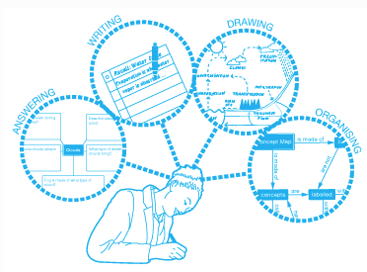  Product Evaluation
Assessment as feedback ensures teaching matches understanding | Become effective at generating strategies to solve problems | To collect a visual record of their work as a way of communicating their thinking and a response to their visual investigations. | To investigate and critique the design criteria and make links to their own work.
Direct Teaching develops novice schemas of knowledge | Their own work becomes more innovative and they take risks with design | Sketch books in which to record, research and generate observations and their own designs, help to embed visual knowledge and retention of memory. | Testing and evaluating their final product will help them to realise the purpose of design.

