
Marchwood Junior School – Computing Curriculum

Children and staff can use computational thinking, creativity and information communication technology to engage safely in and understand the computing world around them.

Intent:
Develop knowledge of…
- Computational thinking – decomposition, pattern recognition, abstraction and algorithms
- Computer systems
- Information Communication Technology (ICT)
- The internet and how to make choices to keep safe
- A range of computing hardware
- Varied computer programmes

Develop an understanding of
- Different programmes can be used for different purposes
- Communicating with some computational language
- How to solve (debug) their own problems
- How the computer systems around them work
- ICT which is at a level suitable for the next stage of work or learning
- The choices they can make when working on digital devices
- How to use their knowledge within programming for desired outcomes
- Different hardware has different purposes

Communicate outcomes through a range of computing software.

Implementation:
How do we help children develop knowledge into schema in their long-term memory?

Whole – Part – Whole | Regular recall of knowledge | Combine visual with text | Grouping knowledge | Spaced Learning
Challenge resides in the curriculum and not in the individual lesson | The act of retrieval strengthens memory, making information more retrievable. | Images can be more easily remembered than words and provide a memory cue | Understanding is the connections that form between knowledge | Spacing recall helps create defined pathways in memory  Knowledge moves from episodic to semantic
Composite questions are broken down into their specific components of knowledge | Frequent low stakes testing of key computing knowledge | Class mind maps are used to show learnt knowledge and provide a stimuli to recall. | Computing mind maps organise knowledge  New knowledge is connected to pre-existing knowledge | Low stakes testing revisits prior knowledge

Avoid overload | Feedback Loops | Articulate knowledge and understanding | Hardware
Working memory has a limited capacity. Learners cannot be overwhelmed with too much. | Assessment as feedback ensures teaching matches understanding | Articulating understanding demonstrates individual schema | Computing allows children to explore a range of hardware and software which can allow children to make choices and change the computing world (in the future)
Knowledge is broken down into clearly defined parts. | Direct Teaching develops novice schemas of knowledge; AfL is used to teach from the correct starting point; systematic monitoring ensures all children gain the required knowledge. | End of unit tasks demonstrate understanding of the key knowledge. | The computing curriculum uses a range of hardware and software. Children have the opportunity to use different hardware in a range of areas of the curriculum
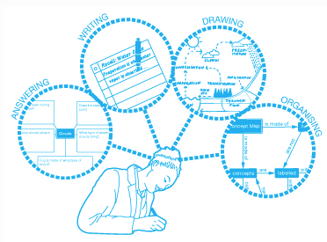
(January 2020)

