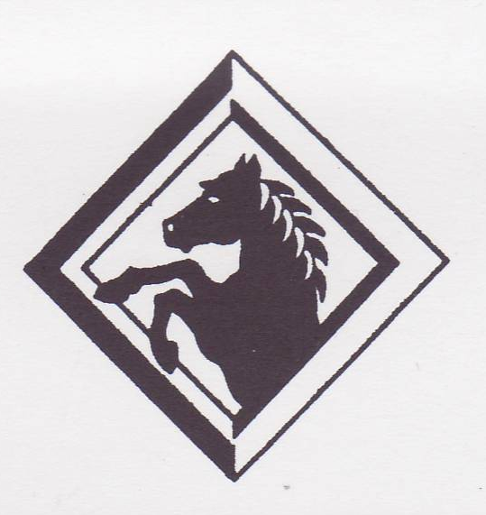
Marchwood Junior School – Art Curriculum

Inspired creative image-makers

Intent:
Develop knowledge of…
- Various techniques in a range of media including 2 and 3D media and digital media (procedure knowledge)
- Great artists, architects and designers in periods in history
- The stylistic elements of artistic works
- Artistic terminology

Develop an understanding of…
- How they can experiment and create within visual art
- Cultural links within art and their developments
- Local, contemporary and industrial/applied contexts
- How to develop control and more skilful handling of more varied techniques

Develop a mastery of…
- Drawing
- Painting
- Sculpture
- Printmaking
- Digital technologies

Critically discuss the impact of artists’ choices, through observation, discussion and creative responses.

Implementation:
How do we help children develop knowledge into schema in their long-term memory?

Whole – Part – Whole | Regular recall of knowledge | Grouping knowledge | Spaced Learning | Avoid overload
Challenge resides in the curriculum and not in the individual lesson | The act of retrieval strengthens memory, making information more retrievable. | Understanding is the connections that form between knowledge | Spacing recall helps create defined pathways in memory  Knowledge moves from episodic to semantic | Working memory has a limited capacity. Learners cannot be overwhelmed with too much.
Complex works are broken down into their specific components and developed | Frequent low stakes testing of significant historical details and terminology | Class mind maps organise knowledge  New knowledge is connected to pre-existing knowledge | Low stakes testing revisits prior knowledge | Knowledge is broken down into clearly defined parts.

Feedback Loops | Creative responses | Visual diaries | 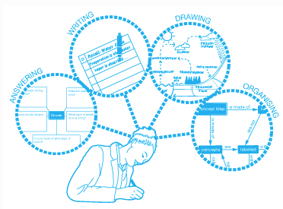  The work of Great Artists
Assessment as feedback ensures teaching matches understanding | Become increasingly aware of the broad diversity of creative practice across the visual arts. | To create visual diaries of their work as a response to their visual investigations. | To investigate and critique the work of significant Artists and make links to their own work.
Direct Teaching develops novice schemas of knowledge | Their own work becomes richer with creativity and individuality. | Sketch books in which to record, research and generate observations and their own designs, help to embed visual knowledge and retention of memory. | Creative responses to an artist’s work will make them reflect on their own work and how this informed their own creative actions.

