
Marchwood Junior School - Cognitive Ability Development

Knowledge is generative and must be precise in detail, building upon the knowledge already acquired.

Learning is an alteration in long-term memory. If nothing has altered in long-term memory, nothing has been learned.

Our Intent:
- A rich web of knowledge and experience which provides the capacity for children to learn even more and develop their understanding through application.
- Content which provides children with subject specific knowledge and vocabulary that allows them to build links and enhance learning.
- Knowledge that leads towards creativity, innovation, purpose and is meaningful (i.e. not a pub quiz) e.g. Coast to Coast.
- Children learn whatever they need to in a range of real world contexts

Our Implementation:
How do we help children develop knowledge into schema in their long-term memory?

Whole – Part – Whole | Regular recall of knowledge | Combine visual with text | Grouping knowledge | Spaced Learning
Challenge resides in the curriculum and not in the individual lesson | The act of retrieval strengthens memory, making information more retrievable. | Images can be more easily remembered than words and provide a memory cue | Understanding is the connections that form between knowledge | Spacing recall helps create defined pathways in memory  Knowledge moves from episodic to semantic
Composite problems are broken down into their specific components of knowledge | Frequent low stakes testing  Varying practice | Knowledge organisers | Class mind maps organise knowledge  New knowledge is connected to pre-existing knowledge | Low stakes testing revisits prior knowledge

Avoid overload | 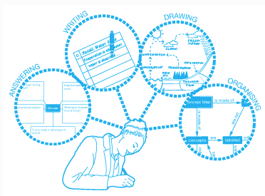  Feedback Loops
Working memory has a limited capacity. Learners cannot be overwhelmed with too much. | Assessment as feedback ensures teaching matches understanding
Knowledge is broken down into clearly defined parts.  Learning environments are engineered to support the acquisition of new knowledge. | AfL  Fluid grouping  Direct Teaching  Worked examples  Split inputs  Systematic monitoring  Intervene

(April 2019)

