
Local points of contact
Marchwood Parish Council
https://www.marchwoodparish.gov.uk/
office@marchwoodparish.gov.uk
02380 860273
- You can access an online copy of the Marchwood Village News magazine on this site
- You can access help and support for local residents on this site
- You can access information about local events and news on this site

Marchwood Village Hall
Telephone number: 023 8066 7927
Email: info@marchwoodvillagehall.co.uk

Maps
Marchwood
https://www.google.com/maps/place/Marchwood,+Southampton/@50.8944376,-1.4528469,15z/data=!4m6!3m5!1s0x4874764b10d04601:0x8c3771b5aba178c2!8m2!3d50.8918843!4d-1.4483102!16zL20vMDNkX2Rn?entry=ttu
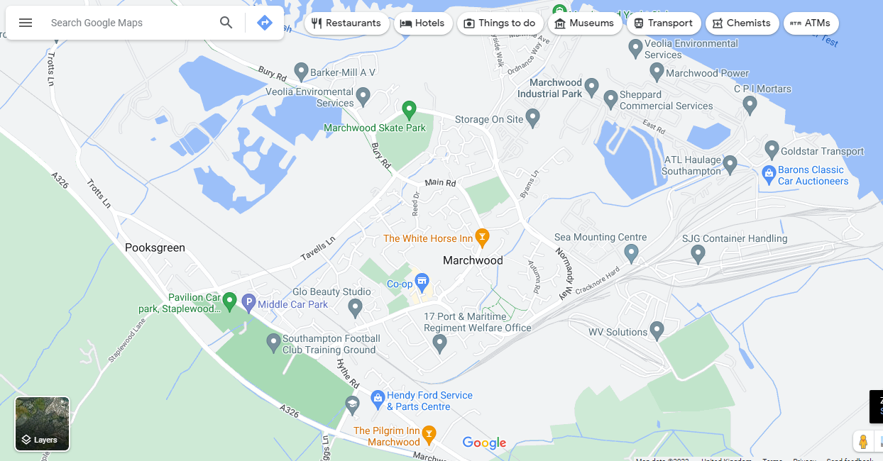
Surrounding area
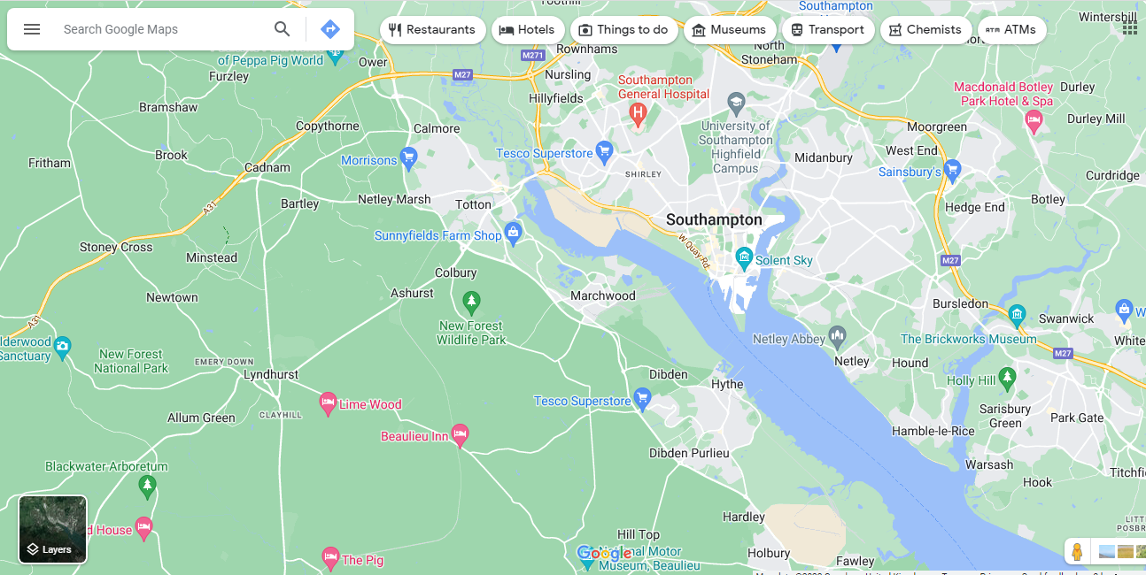

New Forest
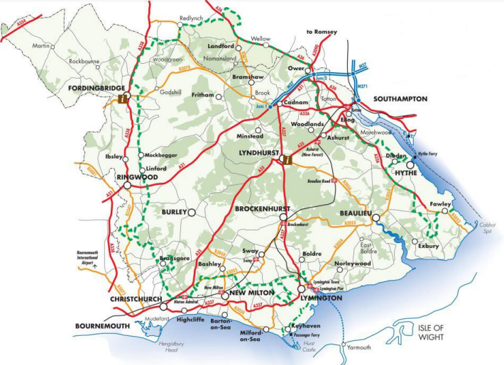

Local schools/ pre-schools/ nurseries:
Twiggs Lane PreSchool
www.twiggslanepreschool.com
02380 675818

Mulberry Pre School
www.mulberrypreschoolmarchwood.com/
02380660354

Little Gardners Nursery
www.littlegardners.co.uk
02380 868700

Forest Stars
https://forest-stars.ueniweb.com/?utm_campaign=gmb
07554202128

Activities for younger siblings

Marchwood Village Hall
023 8066 7927 - Allie Sherwood
Email: info@marchwoodvillagehall.co.uk

Marchwood Tots – Thursday 9.30am – 11.00am £1.70 per child includes refreshments.

The Gospel Church – Long Lane
Wednesdays: 10.30am – 11.30am
Welcomes all Babies, Toddlers and their Grown-ups for Toys, Crafts, Singing, Bible Stories, Library and Snacks – free

Hythe Library – lots of activities to choose from…
https://www.hants.gov.uk/librariesandarchives/library/libraryfinder/hythe-library

Marchwood Infant School
https://www.marchwood-inf.hants.sch.uk/
02380 868819

Marchwood Junior School
https://www.marchwood-jun.hants.sch.uk/
02380 863105

Applemore College
https://www.applemore.hants.sch.uk/
02380 848804

Noadswood School
https://www.noadswood.hants.sch.uk/
02380 840025
Before school /after school / holiday care
https://planet-kids.co.uk/holiday-club
https://planet-kids.co.uk/locations-%26-pricing
https://www.childcare.co.uk/search/Childminders/Marchwood/After-School

https://www.netmums.com/local/marchwood/pregnancy

Clubs and activities for children in the area
Marchwood Hub – Youth Club
Handy Trust Lizzie (find her on Facebook)
This facility is open to all youth. There is a youth club on a Monday night 6pm – 7.30. £1.00 entry. Year 5 onwards.

Marchwood Scouts & Guides
Contact Group Scout Leader Brenda Knight
gslmarchwoodscoutgroup@gmail.com

Marchwood Rangers Football Club
david.pressey5@googlemail.com

Fawley Rugby Club
juniorchair@fawleyrfc.co.uk

Tottonians Rugby Club
julie@tottonians.com

Hythe and Dibden Cricket Club
cappers1001@yahoo.co.uk

Fawley Cricket Club
fawleycricketclub@hotmail.co.uk

Dancewise
www.dancewisestudios.com

Waterside Gymnastics
enquiries@watersidegymnastics.co.uk

Waterside Taekwondoclub
https://l.facebook.com/l.php?u=https%3A%2F%2Fwww.watersidetaekwondoclub.co.uk%2F&h=AT35z2_-Tcfi41_6iqqC1C3ZcZDWvSv2DcQI07MXh5xaancqtxrETGQlgPWFEU7wUlVelhUqG61qqZ1GY08aYqp9a_lm9HW7kRRU1UIe9E7vd0NMWzVHxezatn6psH1cNo28AiyzqOKzdc_UKAAYGA

Waterside tennis club
https://www.facebook.com/WatersideTennisHolbury/?locale=en_GB

Hythe library – range of activities for all ages…from singing to craft to storytime….
https://www.hants.gov.uk/librariesandarchives/library/libraryfinder/hythe-library

Waterside Table tennis club
http://watersidettc.co.uk/

Hockey
https://www.trojanshockey.co.uk/junior-hockey

General sport info
https://www.netmums.com/local/marchwood/sports

Ideas for days out/activities with children

https://www.dayoutwiththekids.co.uk/things-to-do/south-east-and-london/hampshire/marchwood



https://www.eventbrite.ie/b/united-kingdom--marchwood/family-and-education/children-and-youth-/

https://www.netmums.com/local/marchwood/activities

https://www.netmums.com/local/marchwood/events

Isle of Wight
https://www.visitisleofwight.co.uk/
https://www.redfunnel.co.uk/en/book/ferry-booking/
https://www.wightlink.co.uk/plan-your-journey/routes/lymington-yarmouth

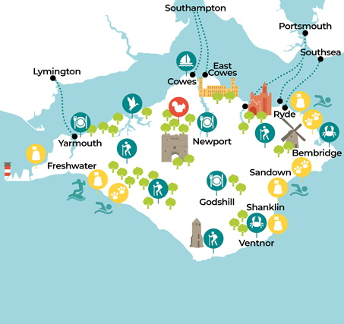

Play areas in Marchwood

Lloyds Recreation Ground - SO40 4XB
Marchwood Village Play Area (behind the Village Hall) – SO40 4SX
Ordnance Way Play Park – SO40 4UX

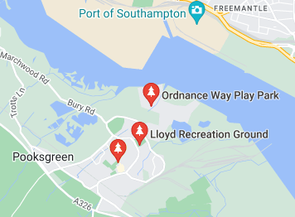

Skate parks near Marchwood

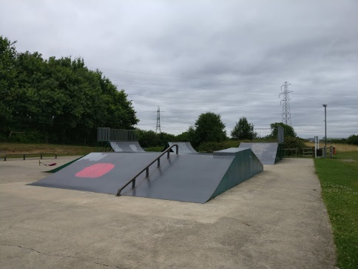
Marchwood Skate Park – SO40 4SR

Bartley/Totton Skate park – SO40 7EA

Hardley Skate Park – SO45 3PQ

Fawley Skate Park – SO45 1GA

The New Forest
Things to do:
https://www.forestryengland.uk/things-to-do
https://www.forestryengland.uk/search-forests?place=New%20Forest%20National%20Park&activity=0&id=ChIJZ9beqM-Gc0gRKgI8N3oFVps&lat=50.8764416&lng=-1.6312373&radius=30&map=0
Walks:
https://www.thenewforest.co.uk/things-to-do/walking/
Marchwood Inclosure
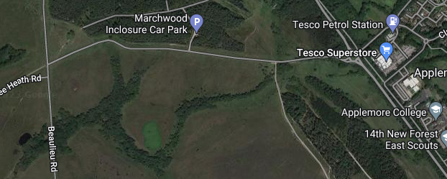
Location : SU 39195 07349
Distance : 4.6 miles
https://newforestcarparkwalks.wordpress.com/2020/11/10/71-marchwood/

Beaulieu to Buckler’s Hard
2 miles
Starting point: Beaulieu village centre
what3words ///cheetahs.swerving.mammoth

Ashlett Creek to Calshot
Distance: 2.8 miles (4.5 km)

Duration: 1-2 hours

Local facilities: Public toilets and parking at Fawley town square. Jolly Sailor pub, Ashlett. Cafe and toilets at Calshot Activities Centre. Public toilets, parking and seasonal cafe at Calshot.

Accessibility: Easy walk along level ground with five gates. Section of path is tidal (alternative upper path).
Top 4 places to go walking in the New Forest

There are many different walks to explore in the forest, but here are some of most popular walking routes you can find….
- Bolderwood: Radnor Trail (1.9 miles)
This fantastic medium walk passes through sweet chestnut, oak and beech dating from the 1860s. Head towards the beautiful Bratley Water, which makes for the ideal spot to rest and enjoy a picnic. The trail will then lead you to the Bolderwood deer viewing platform where you can often see Fallow Deer and at certain times of the day you can see them being fed by the local rangers.

- Keyhaven Marsh (3.5 miles)
Perfect for families and also those with accessible needs. This 3.5 mile walk follows a lovely path along the coast, where you can enjoy breathtaking views across the Solent to the Isle of Wight and the Needles. There's lots of wonderful bird life at Keyhaven Marshes for you to enjoy.

- Burley Village Walk (4.2 miles)
Burley is a quirky village in ther New Forest, where you can find wonderful pubs and tasty handmade fudge. On this trail, you'll head out of the centre of the village and explore around the edge on a circular walk. Enjoy the gentle uphill climb along Castle Hill Lane, where you'll find amazing views across the Avon Valley. You'll also pass an ancient fort, open forest and woodland.

- Lyndhurst on foot (8.5 miles)
Discover the ‘heart’ of the New Forest at Lyndhurst. What better way to do this than on foot! This circular walk extends through the parish of Lyndhurst and passes by several pubs, perfect for a break in your journey! A lot of the 8½ mile route is on the footpaths and bridleways which surround the town, with only small sections of the walk taking place on roads.
See how many New Forest ponies and other animals you can spot along the way.
This walk can be enjoyed all year around, although we would recommend that you wear appropriate clothing and footwear, particularly in the colder months.
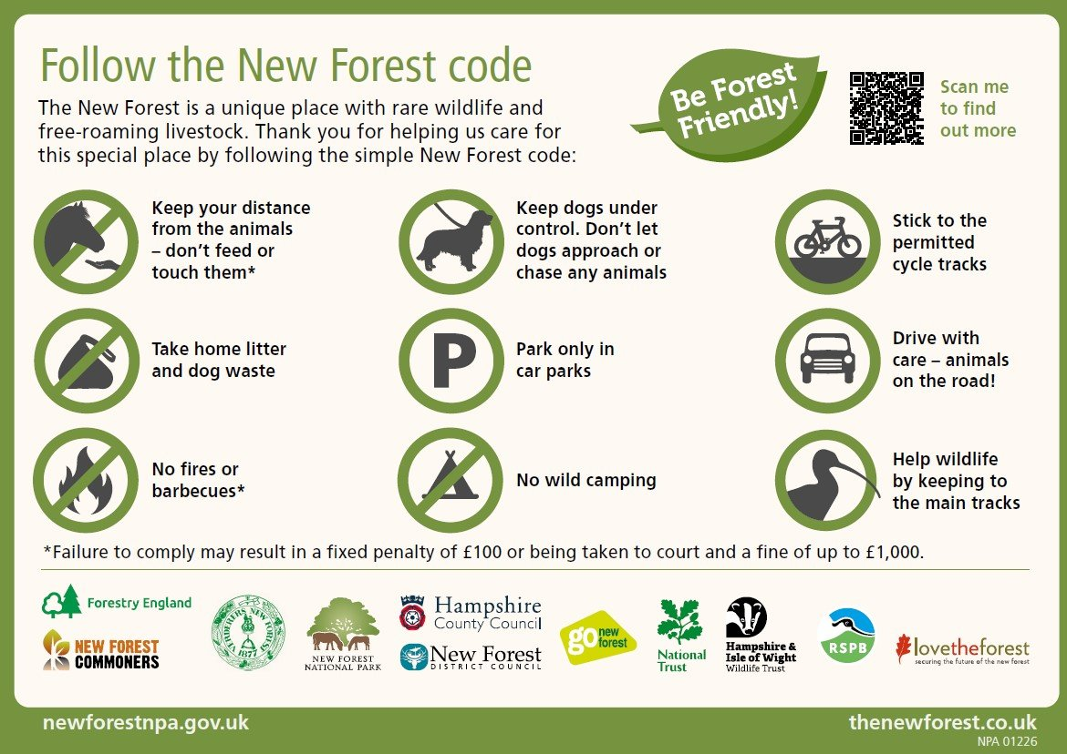

What’s on in the forest….
https://www.thenewforest.co.uk/whats-on/


On the coast….
Maggie beach
Maggie Beach is a beach, located at: Quayside Walk, Marchwood, Southampton, SO40 4AB.
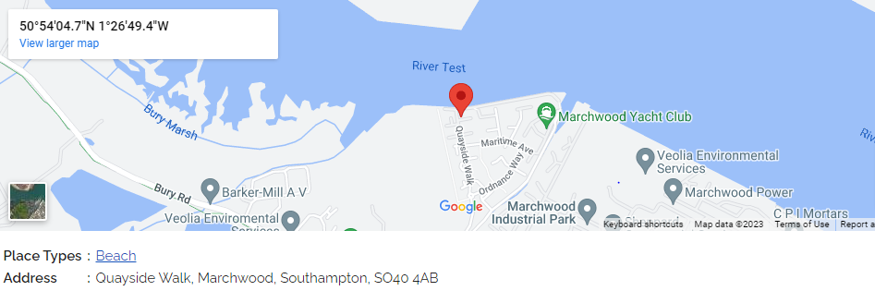
Lepe Country Park
A stony beach that forms part of Lepe Country Park, situated in an Area of Outstanding Natural Beauty. Views across to the Isle of Wight and excellent coastal walks featuring pine-fringed cliffs, D-day remains and wild flower meadows.
Lots of activities for adults and families throughout the year….walk the Lepe Loop, follow the nature trail or play in the park, plus lots of seasonal activities with the Rangers and even food and music nights at the Lepe Lookout!
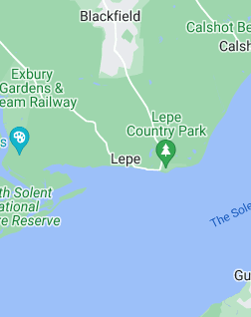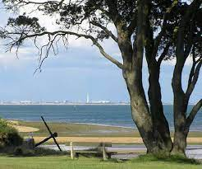
Lepe Country Park
Exbury
Southampton
SO45 1AD
https://www.hants.gov.uk/thingstodo/countryparks/lepe/visit

Calshot
Calshot beach forms part of a mile long shingle spit which reaches out into the mouth of Southampton Water. From here you get a great view of the ships coming and going from one of the UK’s largest ports.
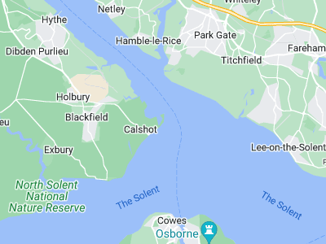
The beach also offers panoramic views of the Solent, Southampton and the Isle of Wight so it is little wonder the beach is the site of a 16th century castle. Built in 1539 by Henry VIII, Calshot Castle is one of number of similar forts built to defend the south coast from the French and Spanish.
Calshot beach is home to one of the UK’s biggest outdoor and watersport centres. The Calshot Activities Centre offers a range of activities including windsurfing, kitesurfing, sailing and climbing. The centre is located in a hangar which was built to house the flying boats of the Calshot Naval Air Station.
On the other side of the spit is an extensive salt marsh which is home to a wealth of birds and other wildlife.

Calshot Castle

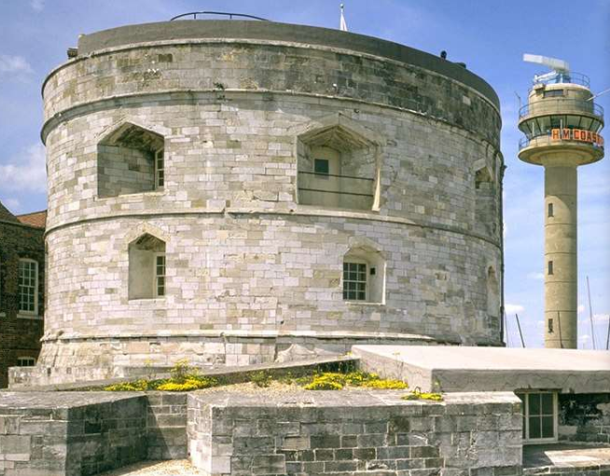
https://www.english-heritage.org.uk/visit/places/calshot-castle/

Calshot Activities Centre
https://www.hants.gov.uk/thingstodo/outdoorcentres/ourcentres/calshot
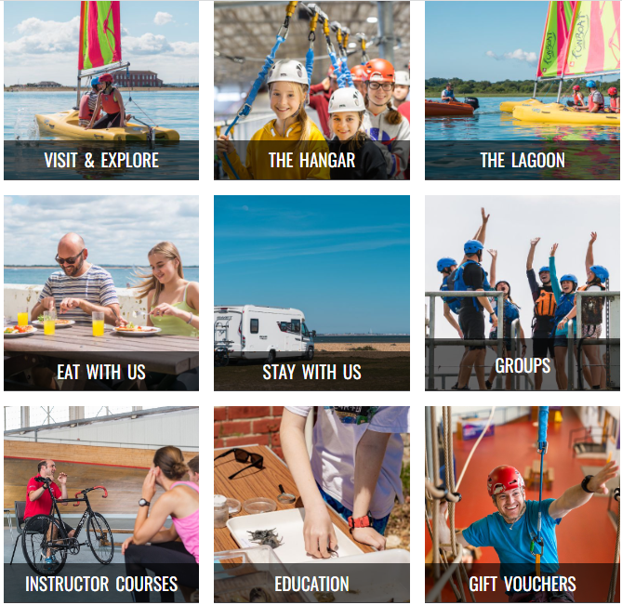
Lots of different activities for all members of the family!

Clubs and activities for adults in the area
Waterside taekwondo club
https://l.facebook.com/l.php?u=https%3A%2F%2Fwww.watersidetaekwondoclub.co.uk%2F&h=AT35z2_-Tcfi41_6iqqC1C3ZcZDWvSv2DcQI07MXh5xaancqtxrETGQlgPWFEU7wUlVelhUqG61qqZ1GY08aYqp9a_lm9HW7kRRU1UIe9E7vd0NMWzVHxezatn6psH1cNo28AiyzqOKzdc_UKAAYGA
Totton Sharks Ladies Basketball
email: tottonsharksbasketball@gmail.com
call: 07765975485
Cricket
Fawley Cricket club
https://fawleycc.play-cricket.com/home
Hythe and Dibden cricket club
https://www.hythe-dibdencricketclub.co.uk/
Applemore Health and Leisure
https://www.freedom-leisure.co.uk/centres/applemore-health-and-leisure/
Totton Health and leisure
https://www.freedom-leisure.co.uk/centres/totton-health-and-leisure/
Golf – Dibden
https://www.newforest.gov.uk/article/1202/Dibden-Golf-Centre
Football
Men:
https://www.hampshirefa.com/players/men
Women:
https://www.hampshirefa.com/players/women
Gym
https://www.room13fitness.com/
Sports and fitness events
https://www.eventbrite.com/b/united-kingdom--marchwood/sports-and-fitness/
Marchwood yacht club
https://marchwoodyc.org.uk/
Calshot sailing club
https://calshot-sailing.co.uk/

Tennis
Totton tennis
https://www.totton.tennis/
Waterside Tennis club
https://www.facebook.com/WatersideTennisHolbury/?locale=en_GB
Waterside Bowls
https://www.watersidebowls.co.uk/
Netball
https://www.facebook.com/calmorenetballclub/?locale=en_GB
Hockey – men and women
https://www.trojanshockey.co.uk/contact
Hythe library– range of activities and support – from art workshops, learning about computers, knitting etc
https://www.hants.gov.uk/librariesandarchives/library/libraryfinder/hythe-library

Pilates and Stretch Classes
spolmeer@marchwoodun.co.uk

Marchwood Man Shed
Contact Marchwood Parish Council, Gary Wright or John Case
It will be held on a Wednesday afternoon from 1.30pm – 4.00pm at The Hub, Lloyd Recreation Ground.

Marchwood WI
It is warm and supportive group of like-minded women. Meets on the second Tuesday of the month at 7.15 at the Village Hall. Contact: Judy Saxby 023 80866610
http://hampshirewi.org.uk/wi-page/page/19/

Marchwood Village Hall
023 8066 7927 - Allie Sherwood
Email: info@marchwoodvillagehall.co.uk

Zumba classes
https://www.zumba.com/en-US/class-location/marchwood-village-hall-371442

Community Champions

Age Concern- Horrill Centre | Donna Best donna.best@ageconcernhampshire.org.uk | The Horril Centre is a day centre that provides support for seniors and dementia patients. It also provides much needed respite for carers. They run several activities and craft sessions. Transport can be provided. They can provide a two course lunch. | Can self refer. Private and/or funded.
Waterside Health & Wellbeing Support | hiowicb-hsi.pcnhealthcoaches@nhs.net | Provides a tailored self-care plan with a health coach. Includes assistance with sleep management, postnatal support, fitness and exercise, stress management, weight and healthy eating. They also have current projects being run in the Waterside and online. | This is a free service. Accepts self referrals or GP referrals
Waterside Foodbank | Laura Holloway- Project Manager info@waterside.foodbank.org.uk | The foodbank work on a referral basis and provide food parcels to those in need. They can also provide toiletries and fuel voucher. They have a financial inclusion officer available for people that need help budgeting or who require advice regarding their finances | Agency referral only.
Read Easy | Allison Walker southamptoncoordinator@readeasy.org | Read Easy provide 1 to 1 support for adult literacy. This is a free service. They provide twice weekly sessions with a coach | Self Referral
Citizens Advice- New Forest | newforestcab.org.uk | Advice and support from trained advisors. Includes advice with benefits, bills, debt advice, digital help, housing advice, employment advice, cost of living, referral point for the foodbank. | Self Referral
Solent Mind- Marcella House |  | Free support service offered to people within the New Forest, over 18 and currently experiencing mental health issues. Short-term programme of recovery based course, skills and techniques taught to manage mental health, assigned a key worker during the course. Wellbeing, emotional support provided face to face, telephone, text, email or video call. Peer support also provided. Group courses offered. | Self Referral
Hythe Library |  | Hythe library provide free computer access, wifi, toy exchange, IT support and access to the community fridge. They run several groups for infants, toddlers, children and adults. They are a host for the community fridge which is free to everyone and reduces food waste, also accepts donations. There are also several social groups that are run weekly including games afternoons and Knit & Knatter. | Self Referral
Families Matter | Laura Gray laura.fm.hurc@gmail.com | Currently run 5 support groups, weekly or monthly for different groups, e.g. Parents of children with special needs, Women with mental health issues, people with dementia. Their largest project is run in 8 local schools helping children move up to secondary school with less anxiety. They provide a trusted adult to talk through worries and anxieties in weekly meetings at the school. They give further support in secondary schools where needed through a mentoring programme. 4 parenting courses are also held throughout the year for parents whose children struggle with angry feelings. One to one support is also given to families. Hythe Huddle is a monthly support group for people with dementia and their carers, they provide a programme of music, entertainment and activities. They also run a weekly memory group. There is also a time group which supports families coping with addiction, these sessions are bi-monthly or telephone support is available. Weekly meetings are held for carers of children with additional needs (SWANS), this is a drop-in morning group with one to one home visits offered. This group also arranges activity days and the occasional outing/event during the school holidays. One to one support is offered to vulnerable families, including home visits, assisting with food parcels, support with behavioural problems with children etc. They work in partnership with Social Services and signpost to other services. | Self Referral
Parish of Hythe | Chirs McMahon families@stjohnshythe.org Soraya Hawker office@stjohnshythe.org or 02380844336 | The Parish of Hythe offer a range of activities including a baby group (donation only), toddler group, youth group, senior lunch club, free family movie nights, regular community events and baby sign language courses. They are a referral point for the foodbank and signpost to many other services. | Self Referral
The Crossings | Andy Clarke 07486551272 | The Crossings is a local charity for those facing eviction, sofa surfing or rough sleeping. There are 3 drop-in centres across the Waterside area. Welcoming place to address housing issue, help with housing applications, hot drink, snacks and phone charging facilities available. Help provided with online applications for benefits and NFDC homesearch register. Signpost to other agencies. | Self Referral
Hampshire Healthy Families/Barnardos | Wendy Newman wendy.newman@barnardos.org.uk hhf@barnardos.org.uk | Hampshire Healthy Families offer free courses and workshops for parents. They work in partnership with NHS Southern Health and Barnardos. Attend early year settings and offer a befriending service to assist families to socialise within local groups. They offer social walks within the local area to assist with socialisation | Self Referral
Wessex Cancer Support | Maureen Robb maureen.robb@wessexcancer.org.uk | Wessex Cancer Support offer support groups, complimentary therapies and counselling. Experienced befrienders, supporting anyone affected by a cancer diagnosis in the waterside area. Drop-in service 10am - 1pm and support offered on the telephone 02381780409 | Self Referral
NFDC | Ryan Stevens- service manager- revenues, benefits and customer services | NFDC are working in partnership with Fareshare, Trussell Trust and CAB bringing Food Larders to the local area, this is a low cost membership scheme where members are supplied with up to 25 ready selected food items. | Self Referral
New Forest Aquaponics | Lucie Mann watercressqueen1@gmail.com | Runs Waterside Food Project responsible for Hythe Community Fridge (in Library), Blackfield cook ups, Langley Food Box. Also runs Repair Cafes, Boomerang Bags, Waterside Clothes Swaps. | Self Referral
Yvonne's Kitchen | Tara Moony or Ann McDonald 07928935059 or 07783568280 | Offers free take away meals during the school holidays. Mondays and Thursdays , 12pm collection at side door of St Anne's Neighbourhood Centre. Meals to be booked in advance. | Self Referral

