Marchwood Junior School
Working with you for your children.



Mental Health and Wellbeing Team and support information for families
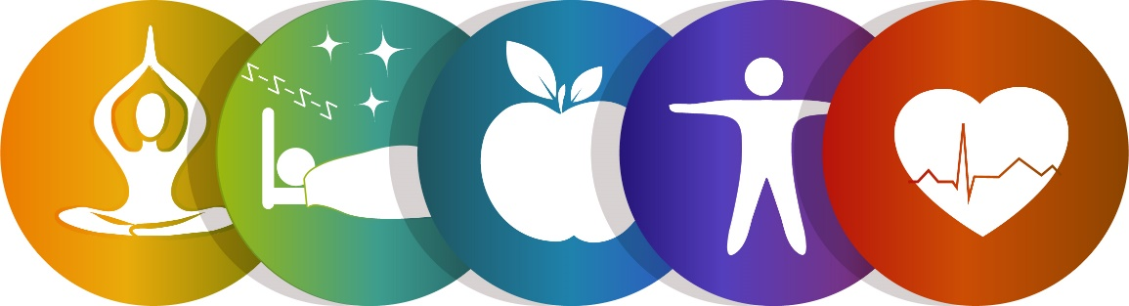

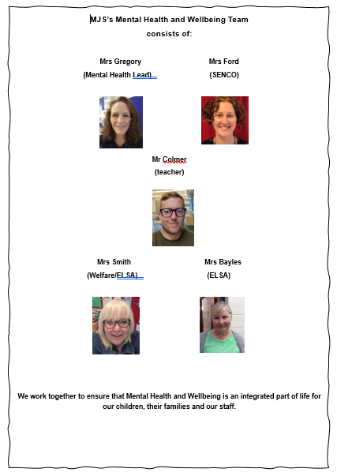
Mental Health Support Team
We are an ‘MHST’ school—this means that we have signed up to a national initiative where Mental Health Support Teams work closely with us in order to offer support to families and children in regard to lower level needs eg anxiety. This means support can be offered quite quickly and often means that situations do not escalate, thus reducing the need for higher level interventions in later years.
We have a designated practitioner working with us (although there is a large team and different members come into our school to work with children and their families) and her name is Ella Lucas. She also works with Marchwood Infant School.



Ella Lucas

Cuppa and Chat


Every half term we run a Cuppa and Chat session for our families. Keep your eyes peeled for dates on our newsletter! Everyone is welcome – even pre-schoolers! It’s a chance to chat about any worries or concerns about your child/ family, meet new people, learn about how MHST can support you, plus discuss key themes which parents have requested help with eg routines, ASC, school avoidance etc, all in an informal, relaxed setting.
We look forward to welcoming you!

Mental Health and Wellbeing Support for families
Useful contacts:
At school (MJS):
Mrs Gregory (Senior Mental Health Lead): tgregory@marchwoodjun.co.uk
Mrs Ford (SENCO): eford@marchwoodjun.co.uk
Mrs Smith (Welfare/ELSA): dsmith@marchwoodjun.co.uk
************
Hampshire CAMHS website: (child and adolescent mental health service)
https://hampshirecamhs.nhs.uk/ (There is a huge amount of advice and support on this website – head to the parent/carers section)
*************
ASD New Forest:
https://www.autism.org.uk/directory/a/asd-new-forest

The National Autistic Society provides help and advice for children with Autism (and those who are waiting for an Autism assessment). They have an Autism Helpline, Education Rights service and Parent to Parent service. More information can be found on their website www.Autism.org.uk or they can be contacted on 0808 800 4104

Parent to Parent is a service run by the National Autistic Society and is a UK-wide confidential telephone service providing emotional support, the opportunity to talk through problems and feelings, suggest helpful strategies and provide a non-judgemental listening ear to parents and carers of children or adults with autism. The service is provided by trained parent volunteers who are parents themselves of a child or adult with autism. More information can be found on the National Autistic Society website www.Autism.org.uk or they can be contacted on 0800 800 4106

Autism Hampshire provides information and advice, including pre, during and post diagnostic support. They also have social groups for parents of children and young people who have a diagnosis of Autism. More information can be found on their website www.AutismHampshire.org.uk or they can be contacted on 02380 766162

Hampshire Specialist Parenting Support Service (HSPSS) delivers evidence-based parenting programmes both in a group setting and individually in family homes to parents with children aged 5 to 17 years who have autism and behaviour that challenges. They provide the ‘Cygnet’ parenting programme for parents to develop a better understanding of Autism and develop positive parenting strategies. For more information call HSPSS on 01489 799178 or complete the online referral form found on their website https://www.barnardos.org.uk/what-wedo/services/hampshire-specialist-parenting-support-service

Koala - Koala offers autistic-led support for autistic and neurodivergent individuals, their families and carers. A diagnosis is not needed. Based at the Bridge in Andover. Support is provided through peer groups, training, drop-ins and much more. www.koalacommunityhub.co.uk

***************
National and local Services Directory:
https://www.safe4me.co.uk/support-services/

***************
Solent Mind:
https://www.solentmind.org.uk/support-for-you/our-services/new-forest-wellbeing-service/

***************
Grandparents Plus:
https://www.grandparentsplus.org.uk/support-group/community-first-new-forest/

***************
Young Minds
https://youngminds.org.uk/

***************
No Limits
https://sid.southampton.gov.uk/kb5/southampton/directory/service.page?id=C3seFbVEAPs

****************
Bullying - Kidscape
Kidscape help families and young people who are being bullied. They run a Parent Advice Line and provide guidance and support for parents and carers of children facing bullying. The website contains a wealth of information for young people, parents and professionals www.KidScape.org.uk.
They can be contacted on 020 7730 3300 or info@KidScape.org.uk

*********************
Hampshire Parent Carer Network:
http://www.hpcn.org.uk/
****************
Place2Be
https://www.place2be.org.uk/our-services/parents-and-carers/
****************
Back to Basics Programme
https://www.hants.gov.uk/socialcareandhealth/childrenandfamilies/back-to-basics
****************
Many young people have found these self-help websites and messenger services useful.
• www.YoungMinds.org.uk - a website that provides information and support for young people including a 24/7 crisis messenger. If you are experiencing a mental health crisis and need support, you can text YM to 85258.
• www.TheMix.org.uk - a website which offers information and support for young people under 25 years old, including a helpline, one-to-one chat, discussion boards and online counselling.
• Chat Health - a secure and confidential text service which allows patients to easily and anonymously get in touch with health care professionals for advice and support. In Hampshire young people can text 07507 332160 and more information can be found on their website www.HealthForTeens.co.uk/health/about-chathealth/
You may find it helpful to make a self-soothe box which can be used when feeling worried. A video demonstrating how to do this can be found on the Hampshire CAMHS website: https://hampshirecamhs.nhs.uk/video/5-of-7-make-your-own-self-soothe-box/
You may also find it useful to look at recipes4wellbeing which can be found at www.sussexcamhs.nhs.uk/resources-recipes4wellbeing/. These cards provide help and advice about how to support young people, what to look out for, and when you should be concerned.
*****************************
ADHD
BRAAIN are a voluntary organisation based on the Surrey and Hampshire borders. They support parents and carers of children with Attention Deficit Hyperactivity Disorder (ADHD) and Autistic Spectrum Condition (ASC) or Special Educational Needs (SEN) by providing them with a single website to find information about local clubs, support groups, financial support, courses and more. More information can be found on their website www.Braain.co.uk or they can be contacted at enquiries@braain.co.uk
The National Attention Deficit Disorder Information and Support Service (ADDISS) provide people-friendly information and resources about ADHD to families and professionals. More information can be found on their website www.addiss.co.uk or they can be contact on 020 8952 2800 or info@addiss.co.uk
‘Helping Hyperactive Kids: A Sensory Integration Approach – Techniques and Tips for Parents and Professionals’ by Lynn Horowitz and Cecile Rost. This book provides a complete overview and explanation of the therapy, as well as practical sensory integration based techniques that can be used by teachers and parents to help the hyperactive child.
****************************
Bereavement
There are a number of organisations who offer support for young people, and their families, who have experienced loss or bereavement. Simon Says support young people in Hampshire with the loss of someone close to them. They work in practical and creative ways and offer a variety of resources including monthly age appropriate support groups, a telephone support line and advice. More information can be found on their website www.SimonSays.org.uk and they can be contacted on Info@SimonSays.org.uk or on their helpline 02380 647 550
Winstons Wish provides face to face, telephone, email, ‘live chat’ and online advice and support to children and families who are experiencing bereavement to help manage their grief. More information can be found on their website www.WinstonsWish.org and they can be contacted on 0808 802 0021
Cruse offer support and advice to children and adults when someone dies. This includes Hope Again which is the youth specific website created by Cruse. More information can be found on their website www.Cruse.org.uk or you can talk to someone directly through their helpline 0808 808 1677.
*******************************
School nurse
They offer confidential advice and support to children, young people and their parent or carers. More information can be found on this website www.SouthernHealth.nhs.uk/services/child-health-services/schoolnursing/
*************************************
Family Support
A referral can be made to the Early Help Hub through your child’s school. The Early Help Hub provides support for the whole family and will discuss your concerns with you, offer advice and suggest the relevant support for you and your family.
Hampshire Young Carers Association have a team of dedicated staff who can help young people who are caring family members with illness or disability. They provide an environment promoting wellbeing and recovery, ongoing support with community activities, an opportunity to meet other people and socialise. They also provide a counselling service. To contact Young Carers call 023 8090 2465 www,hyca.org.uk http://www.youngcarer.com/sites/default/files/mental_illness_booklet_201 1_2nd.pdf
The Children’s Wellbeing Support Service provides much needed early intervention and support for parents of children with Social, Emotional and Mental Health (SEMH) needs which can present in a similar way to Autism, Attention Deficit Disorder, Attachment Disorder, anxiety and poor emotional wellbeing. Referrals are made by health professionals through the Primary Behaviour Service.
Relate offers counselling services for every type of relationship. They provide advice to young people and their families on marriage, divorce and parenting. For more information ring 0300 1001234 or visit their webstie on http://www.relate.org.uk/. Please note this service is means tested.
Home-Start UK is a leading family support charity. They offer support and practical help to families and children facing challenges around mental and physical health, isolation, disability, post-natal depression, money problems and more. More information can be found on their website www.HomeStart.org.uk
*************************************
Domestic abuse
Yellow Door provides support, advice and counselling to young people who have experienced domestic or sexual abuse. They offer a wide range of specialist therapeutic, supportive and preventative services around the issues of sexual abuse and violence: www.yellowdoor.org.uk
The Hampton Trust work to prevent violence, domestic abuse and social isolation. They provide a variety of programmes and services for young people and families. More information can be found on their website www.HamptonTrust.org.uk or they can be contacted on 02380 009 898
The You Trust provide a variety of programmes and services for young people and families. More information can be found on their website www.theyoutrust.org.uk/service/young-people/
****************************************
Helplines and online support
There are a number of organisations who provide helplines and online support for children, young people and their parents or carers.
• www.ChildLine.org.uk or they can be contacted on 0800 1111
• www.YoungMinds.org.uk or they can be contacted on 0808 802 5544
• www.Samaritans.org or they can be contacted on 116 123
• You can call NHS 111 if you or someone you know needs urgent care, including for mental health, but it's not life threatening. If you, or someone else, is in a life threatening situation call 999
• If you are experiencing a mental health crisis and need support, you can text YM to 85258. We know that finding the right support is important, especially if you need someone to talk to right now. We aim to connect every texter to a trained volunteer promptly to provide crisis help.
Community Champions:
On the following pages are identified ‘Community Champions’ who you may wish to make contact with to support you and your family.

Community Champions

Age Concern- Horrill Centre | Donna Best donna.best@ageconcernhampshire.org.uk | The Horril Centre is a day centre that provides support for seniors and dementia patients. It also provides much needed respite for carers. They run several activities and craft sessions. Transport can be provided. They can provide a two course lunch. | Can self refer. Private and/or funded.
Waterside Health & Wellbeing Support | hiowicb-hsi.pcnhealthcoaches@nhs.net | Provides a tailored self-care plan with a health coach. Includes assistance with sleep management, postnatal support, fitness and exercise, stress management, weight and healthy eating. They also have current projects being run in the Waterside and online. | This is a free service. Accepts self referrals or GP referrals
Waterside Foodbank | Laura Holloway- Project Manager info@waterside.foodbank.org.uk | The foodbank work on a referral basis and provide food parcels to those in need. They can also provide toiletries and fuel voucher. They have a financial inclusion officer available for people that need help budgeting or who require advice regarding their finances | Agency referral only.
Read Easy | Allison Walker southamptoncoordinator@readeasy.org | Read Easy provide 1 to 1 support for adult literacy. This is a free service. They provide twice weekly sessions with a coach | Self Referral
Citizens Advice- New Forest | newforestcab.org.uk | Advice and support from trained advisors. Includes advice with benefits, bills, debt advice, digital help, housing advice, employment advice, cost of living, referral point for the foodbank. | Self Referral
Solent Mind- Marcella House |  | Free support service offered to people within the New Forest, over 18 and currently experiencing mental health issues. Short-term programme of recovery based course, skills and techniques taught to manage mental health, assigned a key worker during the course. Wellbeing, emotional support provided face to face, telephone, text, email or video call. Peer support also provided. Group courses offered. | Self Referral
Hythe Library |  | Hythe library provide free computer access, wifi, toy exchange, IT support and access to the community fridge. They run several groups for infants, toddlers, children and adults. They are a host for the community fridge which is free to everyone and reduces food waste, also accepts donations. There are also several social groups that are run weekly including games afternoons and Knit & Knatter. | Self Referral
Families Matter | Laura Gray laura.fm.hurc@gmail.com | Currently run 5 support groups, weekly or monthly for different groups, e.g. Parents of children with special needs, Women with mental health issues, people with dementia. Their largest project is run in 8 local schools helping children move up to secondary school with less anxiety. They provide a trusted adult to talk through worries and anxieties in weekly meetings at the school. They give further support in secondary schools where needed through a mentoring programme. 4 parenting courses are also held throughout the year for parents whose children struggle with angry feelings. One to one support is also given to families. Hythe Huddle is a monthly support group for people with dementia and their carers, they provide a programme of music, entertainment and activities. They also run a weekly memory group. There is also a time group which supports families coping with addiction, these sessions are bi-monthly or telephone support is available. Weekly meetings are held for carers of children with additional needs (SWANS), this is a drop-in morning group with one to one home visits offered. This group also arranges activity days and the occasional outing/event during the school holidays. One to one support is offered to vulnerable families, including home visits, assisting with food parcels, support with behavioural problems with children etc. They work in partnership with Social Services and signpost to other services. | Self Referral
Parish of Hythe | Chirs McMahon families@stjohnshythe.org Soraya Hawker office@stjohnshythe.org or 02380844336 | The Parish of Hythe offer a range of activities including a baby group (donation only), toddler group, youth group, senior lunch club, free family movie nights, regular community events and baby sign language courses. They are a referral point for the foodbank and signpost to many other services. | Self Referral
The Crossings | Andy Clarke 07486551272 | The Crossings is a local charity for those facing eviction, sofa surfing or rough sleeping. There are 3 drop-in centres across the Waterside area. Welcoming place to address housing issue, help with housing applications, hot drink, snacks and phone charging facilities available. Help provided with online applications for benefits and NFDC homesearch register. Signpost to other agencies. | Self Referral
Hampshire Healthy Families/Barnardos | Wendy Newman wendy.newman@barnardos.org.uk hhf@barnardos.org.uk | Hampshire Healthy Families offer free courses and workshops for parents. They work in partnership with NHS Southern Health and Barnardos. Attend early year settings and offer a befriending service to assist families to socialise within local groups. They offer social walks within the local area to assist with socialisation | Self Referral
Wessex Cancer Support | Maureen Robb maureen.robb@wessexcancer.org.uk | Wessex Cancer Support offer support groups, complimentary therapies and counselling. Experienced befrienders, supporting anyone affected by a cancer diagnosis in the waterside area. Drop-in service 10am - 1pm and support offered on the telephone 02381780409 | Self Referral
NFDC | Ryan Stevens- service manager- revenues, benefits and customer services | NFDC are working in partnership with Fareshare, Trussell Trust and CAB bringing Food Larders to the local area, this is a low cost membership scheme where members are supplied with up to 25 ready selected food items. | Self Referral
New Forest Aquaponics | Lucie Mann watercressqueen1@gmail.com | Runs Waterside Food Project responsible for Hythe Community Fridge (in Library), Blackfield cook ups, Langley Food Box. Also runs Repair Cafes, Boomerang Bags, Waterside Clothes Swaps. | Self Referral
Yvonne's Kitchen | Tara Moony or Ann McDonald 07928935059 or 07783568280 | Offers free take away meals during the school holidays. Mondays and Thursdays , 12pm collection at side door of St Anne's Neighbourhood Centre. Meals to be booked in advance. | Self Referral

Support for families
Council Support Schemes
People on low incomes may be eligible for Housing Benefit, Discretionary Housing Payments and Council Tax Support from New Forest District Council.
This will depend on your current circumstances. https://newforest.gov.uk/benefits
As part of the Cost of Living government support package there are small grants available from New Forest District Council
https://www.newforest.gov.uk/householdsupportfund
Speak to a Trained Adviser
Anyone who is struggling financially can get a benefit check and speak to an advisor for free and confidential advice.
A benefit check can ensure that you are receiving all the money you’re entitled to, especially if your circumstances have changed recently.
Speaking to an advisor could also help you find cheaper deals on things like utility bills and make sure you can access any local support.
There are some great projects to help with school uniforms, household goods and hardship grants.
Many of these initiatives need a referral from a local agency such as Citizens Advice.
Visit https://www.newforestcab.org.uk to find all the details of the opening times of Citizens Advice offices in Totton, Hythe, Lymington, New Milton & Ringwood.
Telephone. 0808 278 7860
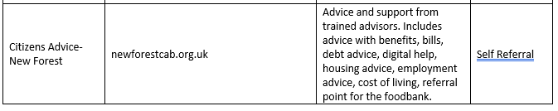
Debt Advice
Debt can happen to anyone. Free advice and support can help you find ways to manage your debts and reduce how much you pay each month.
Citizens Advice New Forest have a specialist debt team. Telephone. 0808 278 7860 to book a free debt appointment.
Step Up Safe Space
This organisation collects donated used school uniforms, clothes and toys to pass on to its members.
https://www.stepupsafespace.com/
Acts 4 Sharing
Collects and distributes donated household goods
https://www.acts4sharing.org/
Dibden Allotments Fund
Helps people in Hythe, Dibden, Marchwood and Fawley who are in hardship.
https://www.daf-hythe.org.uk/

Energy
Contact Citizens Advice New Forest for help with energy bills. Telephone: 0808 278 7860 They will advise on eligibility for any current energy help schemes.

Water Companies
There are three water companies covering the New Forest area, check your water & waste water bills to see which ones cover your area. They all have schemes for people who are struggling to pay their bills:
Southern Water Telephone: 0800 027 0800
Wessex Water Telephone: 0345 600 3600
Bournemouth Water Telephone: 01202 590059

Help to reduce your food shopping bills:
The New Forest Food Larders
Fareshare food larders visit sites across the New Forest with supplies of dried, fresh and chilled food available to FareShare members. It is free to become a member and you only pay a small fee each week for up to 25 food items (dried, fresh and chilled).
Bring your own bags.
1 person household £2.50 per week
2 person household £3.50 per week
4 person household £5.00 per week
MONDAY
Where: Marchwood Marchwood Village Hall, Marchwood Village Centre SO40 4SX
Open: 12:30pm – 1:30pm
TUESDAY
Where: Hythe
St Anne’s Neighbourhood Centre, Warrys Close SO45 3QR
Open: 1.00pm – 2.00pm
WEDNESDAY
Where: Totton
Testwood Baptist Church, 283a Salisbury Road SO40 3LZ
Open: 9.30am – 11.30am
THURSDAY
Where: Blackfield
Queen Elizabeth Recreation Centre, Thornbury Avenue, Blackfield SO45 1YP
Open: 9:30am-10:30am
Where: Calshot
St Georges Hall, 11 Tristan Close SO45 1BN
Open: 12.30pm – 1.30pm

Community Fridges
Community Fridges are publicly available fridges which store unwanted fresh food from the local area, so it can be passed onto those who can make use of it. You don’t need a voucher or referral, anyone can use it, but please only take what you need.
If you want to find your nearest fridge or set up a Community Fridge in your community visit https://www.hubbub.org.uk/the-community-fridge
Open:
Tuesday, Wednesday, Thursday 9.30am – 5.00pm
Friday 11.00am – 1.00pm
Saturday 9.30am -1.30pm
Sunday 4.30pm – 5.30pm

New Forest Food Banks
All areas of the New Forest are covered by Food Banks. They provide food and other essentials for people in an emergency situation. All food banks require a referral from an agency such as Citizens Advice
Telephone: 0808 278 7860
The South
New Forest Basics Bank
https://basicsbank.org.uk/
Telephone: 01590 610008
The Waterside
Waterside Foodbank
https://waterside.foodbank.org.uk/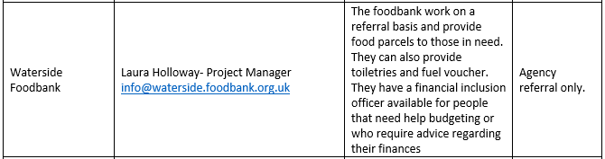
Totton
Telephone: 023 8086 0320
https://www.youthandfamiliesmatter.org.uk/basics-bank/

Food Apps
Too Good to go
Many restaurants, cafes, supermarkets and food brands have partnered with Too Good to Go and provide a “magic bag” of unsold food to users at the end of the working day. It is a scheme to reduce food waste, but also offers food packages at a discounted price. It’s like a goody bag – the items in the bags are always different. Tasty brands include: Greggs, Costa, Morrisons, Starbucks.
https://toogoodtogo.co.uk/en-gb/
Kitche
Keeps track of the foods you purchased from the supermarket and will suggest recipes and warn you when items are getting close to their sell by date.
https://kitche.co/
No Waste
Lets you scan your food and organise it by expiry date, name or category. Makes it easier to monitor what you need to buy in your next food shop so you don’t buy things you don’t need.
https://www.nowasteapp.com/
Olio
Are you going on a diet or did you over order items in your latest shop? This app lets you share unwanted items of food for free among your neighbourhood.
https://olioex.com/

