In this document, you will find maths homework to complete each week for your first half-term in Year 5.

Please hand it in each week on Monday.

If you would like to complete additional maths practice at home, please see below a range of options:

- Practise your times tables on Times Tables Rockstars (login details in your study log).

- Practise a range of maths skills on MathShed (login details, listed under EdShed, in your study log). Click on Stage 4 to recap Year 4 work or Stage 5 to have a go at Year 5 work.

- Go on BBC Bitesize. This is a free resource you can use to practise different maths topics. You can choose your year group and topic with explanations, examples and quizzes.
https://www.bbc.co.uk/bitesize/subjects/z826n39

- Go on Topmarks. This website has a range of games to practise different maths skills, including Hit the Button.
https://www.topmarks.co.uk/Search.aspx?Subject=16&AgeGroup=3

Week 1 – Place Value

Set: Monday 7th September 2026
Due: Monday 14th September 2026

These questions are a recap of some of the place value work you did in Year 4. This will help you as you start Year 5 place value work.

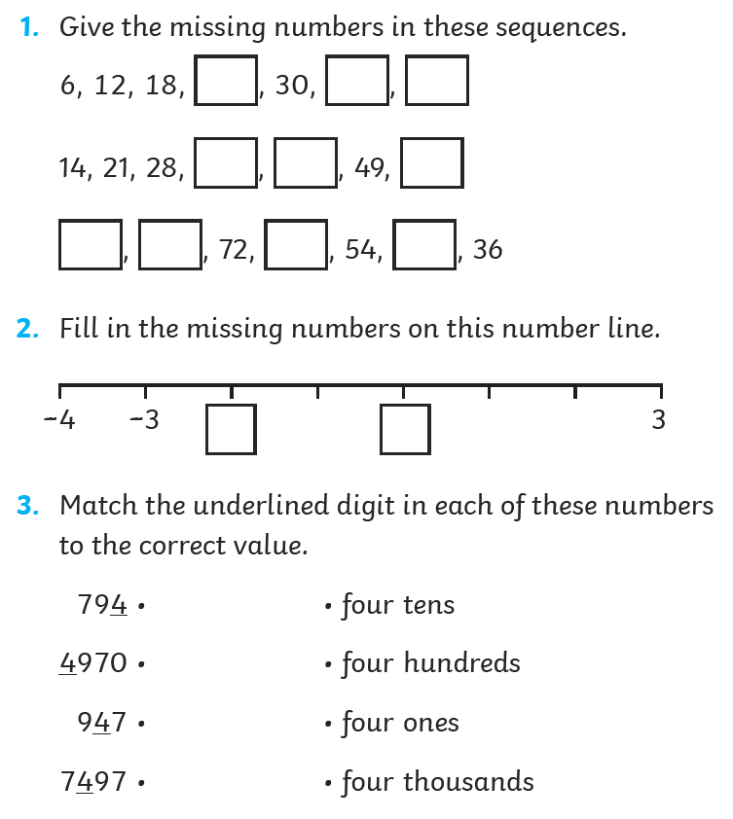
Week 2 – Times Tables

Set: Monday 14th September 2026
Due: Monday 21st September 2026

For your homework this week, please log on to Times Table Rockstars and complete the 20 Garage sessions you have been assigned.

Your login details have been given to you and stuck in the front of your study log.

The times tables have been set to a level at which your teacher thinks you should be able to do. If you have any questions about this, please contact your teacher.

You can access Times Tables Rockstars on a computer, tablet or phone. If you do not have access to a suitable device, please tell your teacher and we will find time for you to complete it in school.

Please note: this is listed as Week 3 homework on the website. Week 2 and Week 3 have been swapped round to reflect work completed in maths lessons.

Week 3 – Place Value

Set: Monday 21st September 2026
Due: Monday 28th September 2026

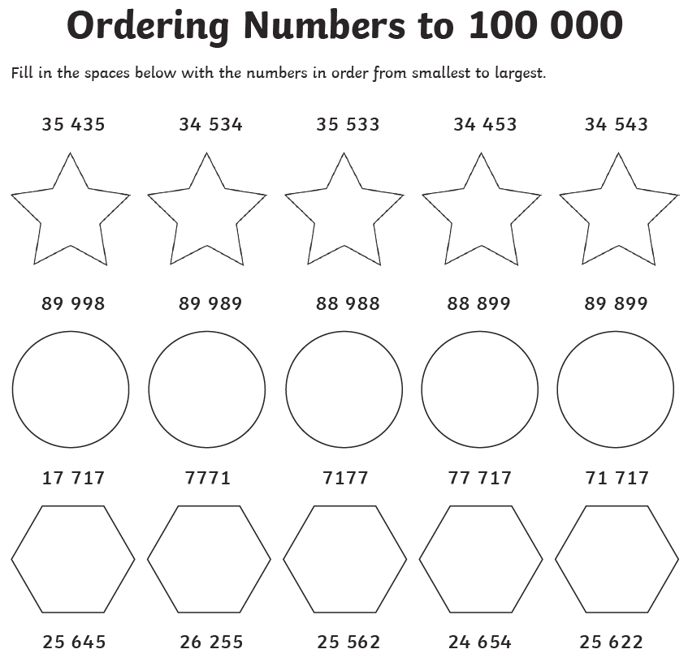

Write these numbers in words and numerals.
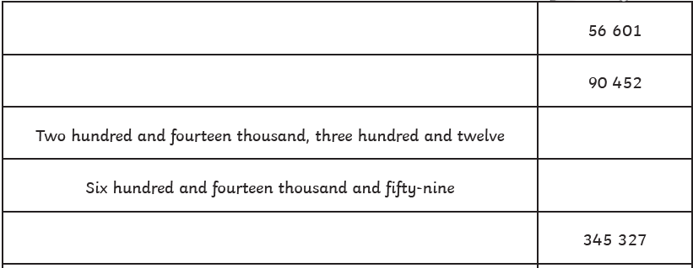

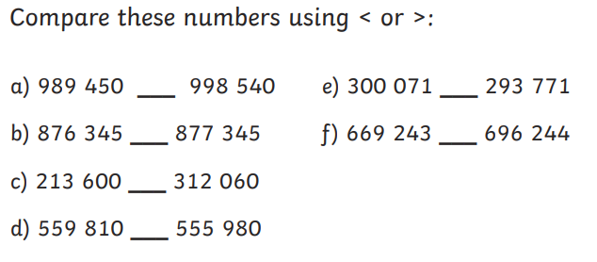

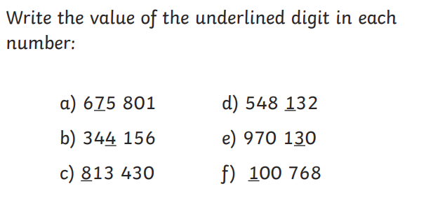

Week 4 – Place Value

Set: Monday 28th September 2026
Due: Monday 5th October 2026

These questions are a recap of some of the work we have done on place value in Year 5.

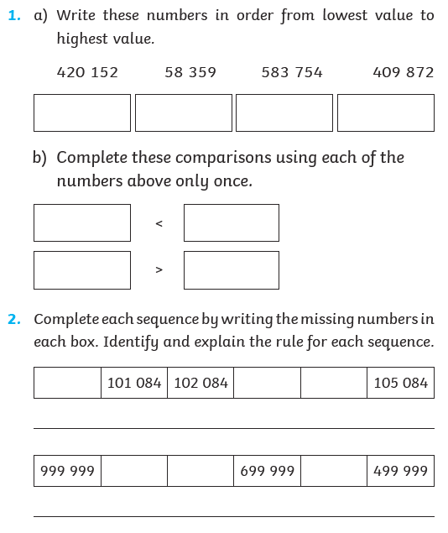

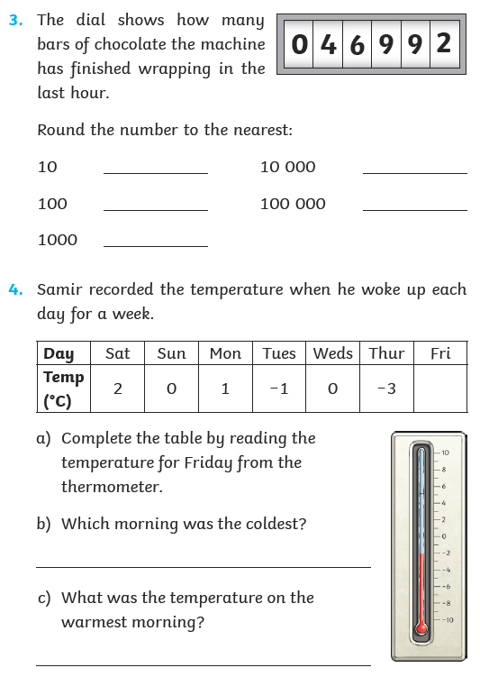

Week 5 – Times Tables

Set: Monday 5th October 2026
Due: Monday 12th October 2026

For your homework this week, please log on to Times Table Rockstars and complete the 20 Garage sessions you have been assigned.

Your login details have been given to you and stuck in the front of your study log.

The times tables have been set to a level at which your teacher thinks you should be able to do. If you have any questions about this, please contact your teacher.

You can access Times Tables Rockstars on a computer, tablet or phone. If you do not have access to a suitable device, please tell your teacher and we will find time for you to complete it in school.

Week 6 – Place Value

Set: Monday 12th October 2026
Due: Monday 19th October 2026

These questions are a recap of some of the work we have done on place value in Year 5.

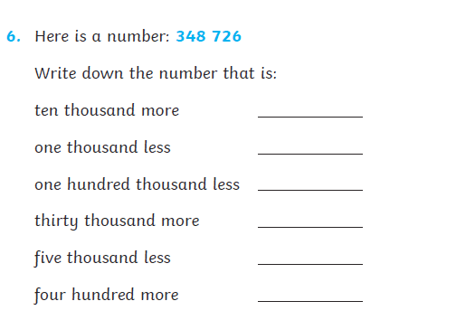

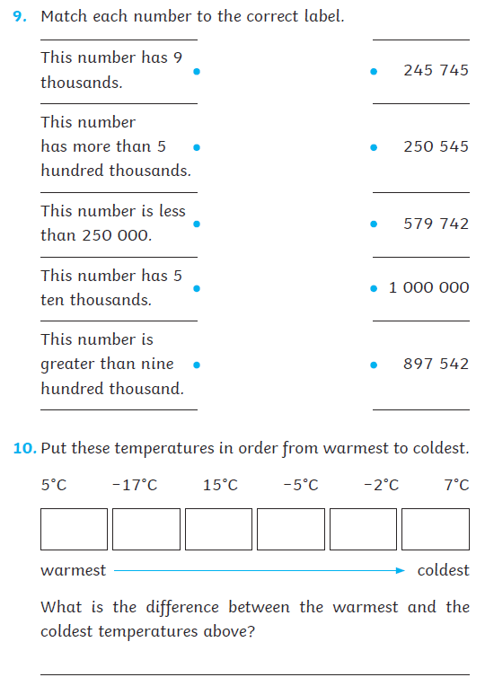

Week 7 – Mixed Arithmetic

Set: Monday 19th October 2026
Due: Monday 2nd November 2026


