

Thursday 1st October 2026
Dear Parents,
We would like to invite you to our first ACE time this year!
This will take place on Wednesday, 21st October 2026 - 2.15pm start time.
Come along and take part in our ‘Our world’ quiz before the children share their learning from this half term. Children and their siblings can be taken home from 3pm if signed out at the office.
Curriculum homework
As you are aware, this half term we will be exploring the world around us and taking an in-depth look at the physical geography of our world.
To further enhance your child’s learning we would like them to carry out further research into one of the physical geography features we will learn about within our lessons.
These physical geography features include:
- Biomes
- Earthquakes and volcanoes
- Lines of Latitude and Longitude and Time zones
- Rivers
- Islands
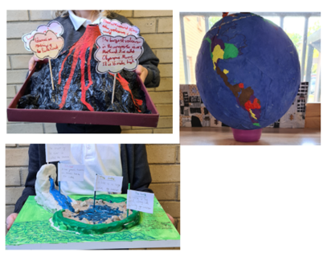
- Mountains
For example, if you child is interested in a particular river like the Amazon, they could research it in detail to create a leaflet, poster, PowerPoint, interactive fact file or even a 3D model.
This could include:
- its location in the world ( including lines of latitude and longitude)
- time zone
- climate
- key facts
They can present their research however they wish but we would like them brought in by Wednesday 21st October 2026 to give all children a chance to share their home learning.

Any questions, please don’t hesitate to ask.
Best wishes,
Year 5 Team.

