Week 5 Homework
- Number bonds to 10.
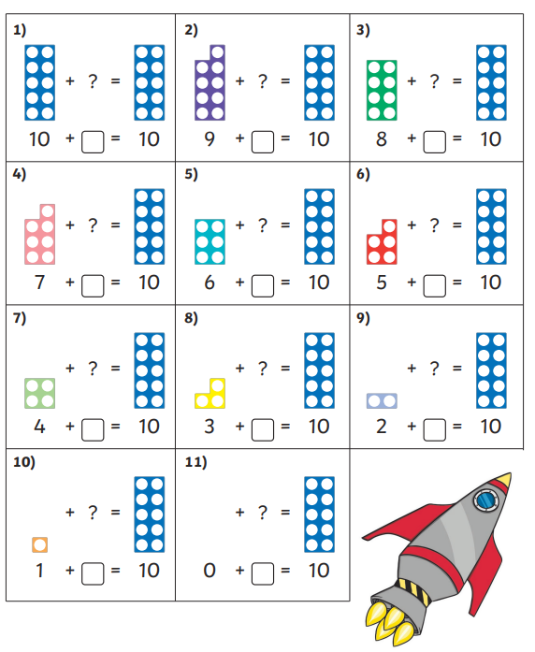
- Fill in the missing numbers.
3, 4, ____ , ____, 7, 8, ____, ____, 11, ____

15, 16, ____, ____, 19, ____, _____, _____
- One more One less
2 17
7 10
19 13

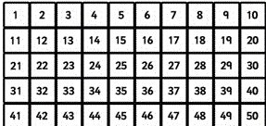
- Count in 2s and colour the number you land on each time.

5.


