Decimal Addition and Subtraction Homework
Once complete, ask a parent to mark your work and if there are any mistakes work with them to make the corrections
You have also been set 15x TTR garage sessions for over half term
Due: Monday 2nd November
Example: |  |  |  |  |  |  |  |  |  |  |  |  |  | “Remember to” steps:
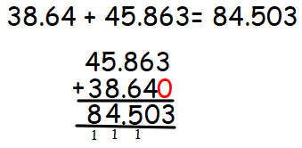 |  |  |  |  |  |  |  |  |  |  |  |  |  | Compact addition with decimals:  -Write out the calculation, lining up the decimal point carefully  -If the numbers are to different amounts of decimal places, add 0  -Add the thousandths  -Add the hundredths  -Add the tenths  -Write in the decimal place  -Add the ones  -Add the tens (and continue to hundreds etc. if necessary)  If necessary: exchange over the digit and write it under the next column. Add it when totaling up the next column.
- 9.63 + 5.6 = |  |  |  |  |  |  |  |  |  |  |  |  |  | - 47.98 + 18.75 =
- 18.74 + 25.88 = |  |  |  |  |  |  |  |  |  |  |  |  |  | - 134.8 + 92.56 =

- 89.03 + 125.6 = |  |  |  |  |  |  |  |  |  |  |  |  |  | - 23.894 + 62.567 =
- 68.903 + 7.85 = |  |  |  |  |  |  |  |  |  |  |  |  |  | - 390.87 + 1,095.9 =
- 92.053 + 375.86 = |  |  |  |  |  |  |  |  |  |  |  |  |  | - 7.905 + 43,853.8 =

Example: |  |  |  |  |  |  |  |  |  |  |  |  |  | “Remember to” steps:
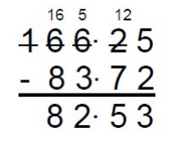  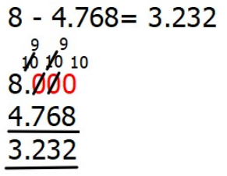 |  |  |  |  |  |  |  |  |  |  |  |  |  | Compact subtraction with decimals:  -Write the first number down, with the second number beneath it. Remember to line up the place value columns. Ensure the decimal places line up.  - -If the numbers are to different amounts of decimal places, add 0  -Subtract the thousandths  -Subtract the hundredths  -Subtract the tenths  -Put the decimal place in the right place  -Subtract the ones, tens, hundreds etc.  -Subtract the tens from the tens column  - Write the answer underneath  - If there is a red alert: exchange from the next column  - Your final answer will be in the box below.
- 36.7 – 18.5 = |  |  |  |  |  |  |  |  |  |  |  |  |  | - 23.94 – 5.63 =
- 78.05 – 18.7 = |  |  |  |  |  |  |  |  |  |  |  |  |  | - 135.83 – 74.1 =

- 156.35 – 107.9 = |  |  |  |  |  |  |  |  |  |  |  |  |  | - 176.805 – 84.32 =
- 5 – 2.15 = |  |  |  |  |  |  |  |  |  |  |  |  |  | - 10 – 5.63 =
- 7 – 3.826 = |  |  |  |  |  |  |  |  |  |  |  |  |  | - 9 – 1.773 =

