Easter Maths Homework

The children have continued to work incredibly hard over the past half term and we appreciate the support you are giving them at home.

With the SATS assessments taking place shortly after the children return from the Easter holidays, it is important that your child continues to do a little maths each day to keep the skills they are learning fresh.

Please find attached 6 days’ worth of revision, which they can plan to do with you over the course of their holiday. In addition to this, we have also provided the children with an arithmetic paper.

Children also have the maths flashcards (from ACE time and children were given these at school to take home if parents were unable to attend) and many parents have purchased the CGP revision books.

If your child would like additional resources to practice specific areas of maths, we would be more than happy to supply this. Please just ask you child to talk to their class teacher.

Thank you again for your time and support.

Year 6 teachers

Please tick below as completed:

Day 1 | Day 2 | Day 3 | Day 4 | Day 5 | Arithmetic

Day 1

4 operation check and do the inverse (opposite) for each calculation to check your answer

128.05 – 12.38 | 323.6 + 356.78 | 345 x 26 | 378 ÷ 18

Fractions of number.

E.g. ¾ of 24 =
24 ÷ 4 = 6
6 x 3 = 18

- 5/6 of 30 =

- 5/8 of 32 =

- 2/9 of 27 =

- 8/9 of 81 =

- 2/3 of 36 =

- ¾ of 88 =

- 2/3 of 96 =

- 4/5 of 315 =

- 5/6 of 210 =

- 6/7 of 182 =

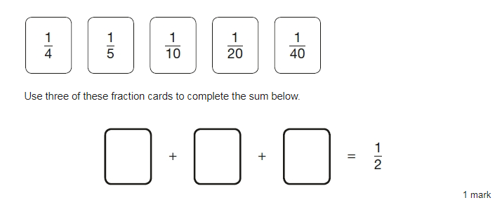
(tip – convert to a common denominator)

Can you convert these fractions into decimals and percentages?

e.g. ¼ = 0.25 = 25%

1 | = |  |  | 3 | = |  |  | 1 | = |  |  | 7 | =
2 | = |  |  | 4 | = |  |  | 5 | = |  |  | 10 | =

Can you complete this number line?

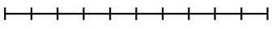

4.0
2.4

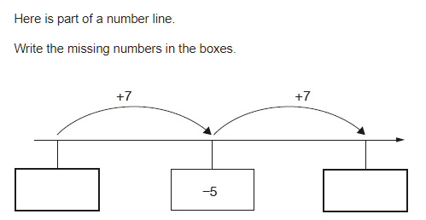

Day 2

4 operation check

7943.76 – 4523.8 | 67,883.63 + 3,856.7 | 1572 x 37 | 1,118 ÷ 26

Can you write two equivalent fractions for each of the fractions below:

e.g. 1/3 = 2/6 = 3/9

1. 2/8 2. ¾ 3. 12/16 4. 2/3 5. 4/10

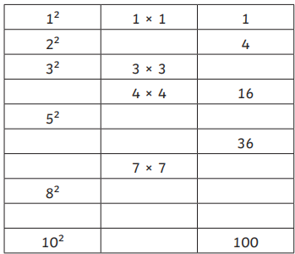
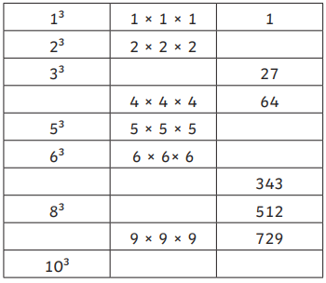

Write each number in its correct place on the diagram.
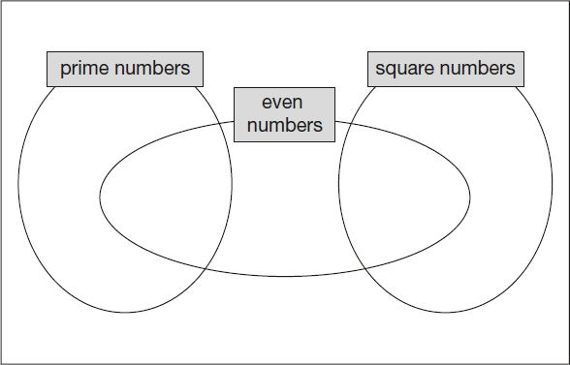
16 17 18 19

Here is a diagram for sorting numbers.
Write one number in each box.
One is done for you.

 | multiple of 5 | not a multiple of 5
multiple of 3 | 30
not a multiple of 3

In the circles, write a multiple that belongs to each set.
One has been done for you.

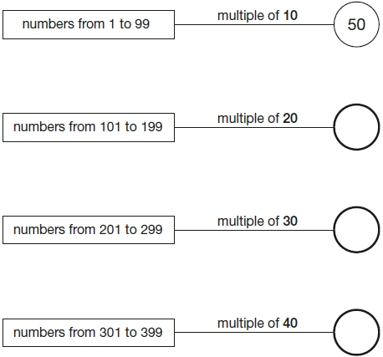

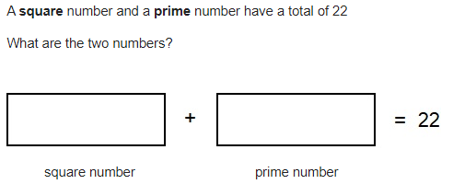

Day 3

4 operation check

382.34 – 95.871 | 9,654.6 + 25,526.78 | 685 x 79 | 4,116 ÷ 42

Calculate the percentage in the grid below?

 | 1% | 10% | 50% | 3% | 5% | 20% | 40% | 15% | 25% | 23%
300
800
1400

30% = 9
70% = ____

20% = 8
40% = ____

25% = 15
100% = ____
15% = 24
50% = ____

e.g. 10% of a number is 6, what is 75% of that number?

10% = 6
5% = 3
70% = 42
75% = 45

Here are some shapes on a 1cm square grid (not to scale)

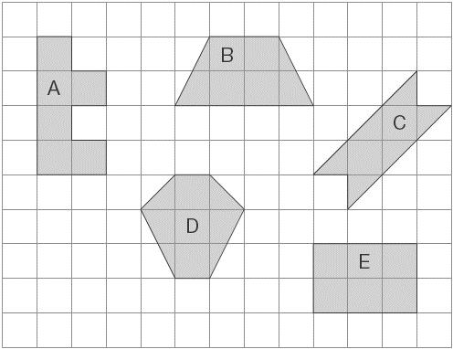
What is the perimeter of shape A?
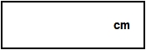

Write the letter of the shape that has the smallest area.
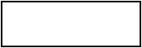

This shape is made from 4 shaded squares.

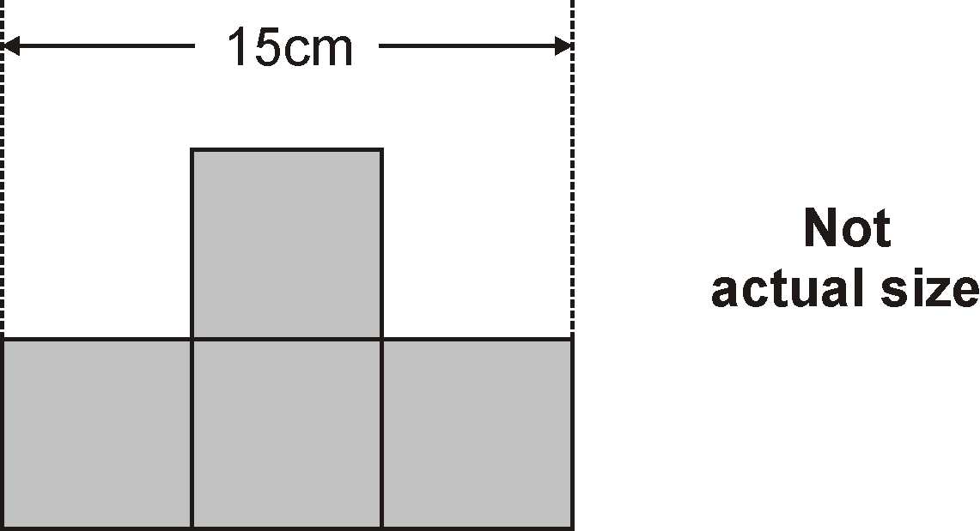

Calculate the perimeter of the shape.

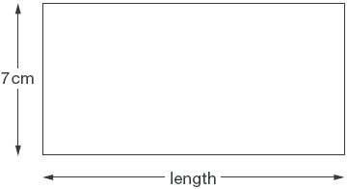
Not actual size
The perimeter of this rectangle is 50 centimetres.
Calculate the length of the rectangle in cm.

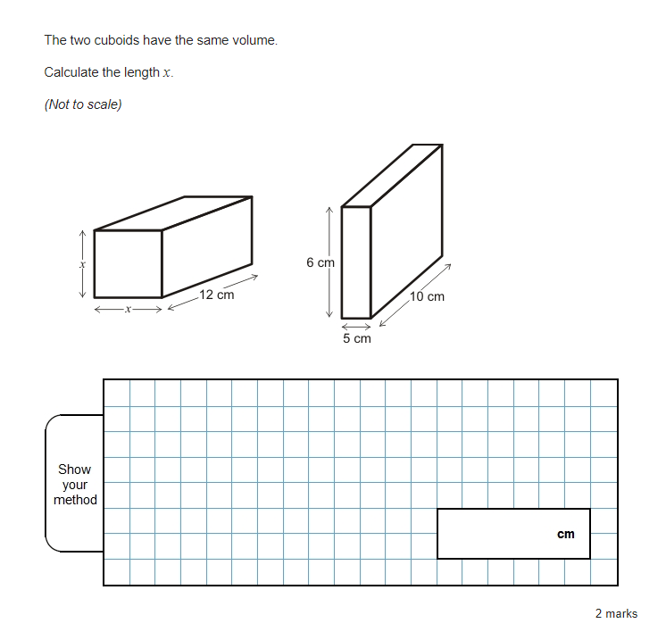
Day 4

Complete at least 10 of the following questions using formal short division (to divide by single digit or 2-digit numbers), short multiplication (to multiply by a single digit) or long multiplication (to multiply by a two digit number). Examples are shown below.

Challenge yourself to complete the column which is most challenging to you. Ask an adult to check your answers with a calculator after you have finished. Can you find the mistakes if you have made any?
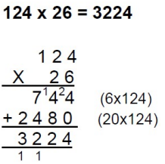
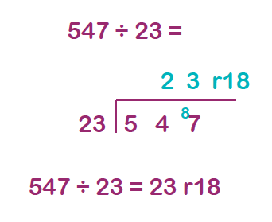
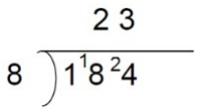
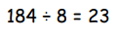
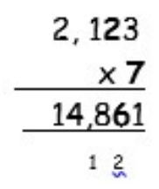

168 ÷ 3 =  285÷ 15 =  148 x 4 =  258 x 26 =  256 ÷ 4 =  800 ÷ 32 =  7,228 x 8 =  294 x 7 =  1,080 ÷ 24 =  4,128 x 56 = | 3,589 x 7 =  1,690 ÷ 65 =  736 x 89 =  8 x 4,726 =  8,342 ÷ 86 =  3,465 ÷ 77 =  7,228 x 8 =  9,786 x 87 =  7,921 ÷ 89 =  47,065 x 79 =

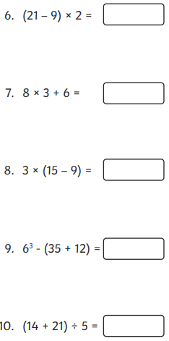
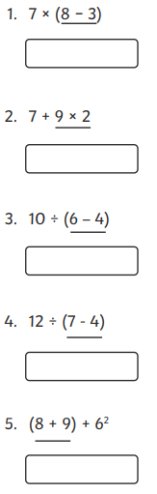
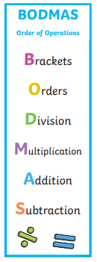

Day 5
Key multiplication facts

6 x 7 | 9 x 8 | 7 x 7 | 9² | 8 x 6 | 90 x 6
7 x 8 | ⁶/₈ x 8 | 7² | 3³ | 12² | 6²
12 x 8 | ⁷/₂₃ x ⁵/₆ | 6 x 7 | 70 x 8 | 70 x 70 | 8 x 8
5³ | 12² | 3/7 x 5 | 6³ | 6 x 8 | 9 x 6
800 x 60 | 60 x 7 | 4³ | 10 x 36 | 8 x 8 | 4.6 x 10
9² | 7 x 8 | 12² | 9 x 6 | 6² | 7 x 70

Get a parent to check your knowledge of these facts. Ask them to time how long it takes you to verbally answer every one of the number facts correctly (you may want to use some jottings for some of the questions). Then try and beat your time. 5 attempts please during the day.

Time 1 | Time 2 | Time 3 | Time 4 | Time 5

Parent’s Signature ___________________________.

Calculate the mean average of the numbers below:
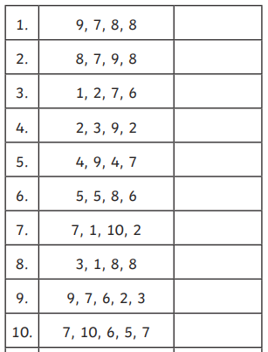

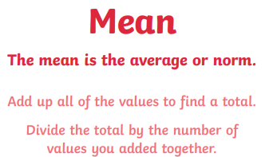
E.g. 8, 7 and 9

8 + 7 + 9 = 24

24 ÷ 3 = 8



