Subtraction Homework

Remember to steps
Number line method

Subtract the tens first, then the ones.
If you are counting back over a tens boundary count back to the tens then another jump after the tens OR just count back in ones.

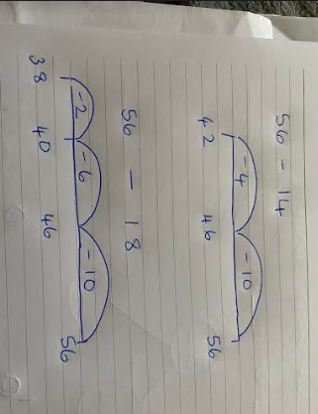

24 - 12

26 - 13

32 - 11

27 - 18

24 - 18

36 – 28

